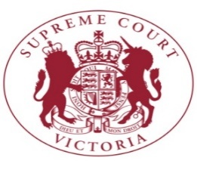
Summary of Judgment

Pell v The Queen
[2019] VSCA 186
21 August 2019

By majority (2 to 1), the Court of Appeal has dismissed Cardinal George Pell’s appeal against his conviction for the commission of sexual offences. He will continue to serve his sentence of 6 years’ imprisonment. He will remain eligible to apply for parole after he has served 3 years and 8 months of his sentence. Whether Cardinal Pell will be released on parole will be a matter for the Adult Parole Board, not the Courts.
Context
Before describing in summary form why the Court has reached the decision it has, there is some relevant context of note.
Late last year, Cardinal Pell was convicted of five specific sexual offences alleged to have been committed on two occasions in the mid-1990s when he was the Catholic Archbishop of Melbourne. In a previous trial on the same charges the jury were unable to reach a verdict. Cardinal Pell’s position is that he should not have been convicted.
Cardinal Pell’s conviction and this appeal have attracted widespread attention, both in Australia and beyond. He is a senior figure in the Catholic Church and is internationally well known. As the trial judge, Chief Judge Kidd, commented when sentencing Cardinal Pell, there has been vigorous and sometimes emotional criticism of the Cardinal and he has been publicly vilified in some sections of the community. There has also been strong public support for the Cardinal by others. Indeed, it is fair to say that his case has divided the community.
It is important to stress at the outset that Cardinal Pell’s conviction only concerns the five offences alleged to have been committed by him. Again, as the trial judge observed, he was not to be made a scapegoat for any perceived failings of the Catholic Church nor for any failure in relation to child sexual abuse by other clergy. His conviction and sentence could not be a vindication of the trauma suffered by other victims of sexual abuse.
The offences in respect of which Cardinal Pell was found guilty by a County Court jury were one charge of sexual penetration of a child under 16 and four charges of indecent act with a child under 16. The trial lasted for five weeks. The jury deliberated for several days. The jury’s verdict was unanimous.
Each of the three judges sitting on the appeal has watched recordings of the evidence given by 12 of the 24 witnesses at the trial. They have also watched recordings of the view the jury were taken on, the walk through of the Cathedral by the complainant and the recorded interview of Cardinal Pell before he was charged. Those recordings went for more than 30 hours. The judges have watched some of those recordings more than once. The written transcript from the trial is approximately 2000 pages in length. Each of the judges has read that transcript, some parts of it multiple times. Like the jury, the judges were taken to St Patrick’s Cathedral to be shown what the jury had seen.
Grounds of appeal
Cardinal Pell sought leave to appeal from his conviction. As is common, the application for leave and the appeal itself were heard together. There were three proposed grounds of appeal. The main ground was that the guilty verdicts are ‘unreasonable and cannot be supported having regard to the evidence’ (‘the unreasonableness ground’). The second ground concerned the refusal by the trial judge to allow Cardinal Pell’s counsel to use a 19 minute animation in his closing presentation to the jury. The third ground was about whether there was a fundamental irregularity in the trial process based on an argument that Cardinal Pell did not enter his plea of not guilty in the presence of the jury panel.
In a unanimous decision, the Court of Appeal refused leave to appeal in respect of the second and third grounds. Cardinal Pell was successful in seeking leave to appeal in relation to the first ground. However, by majority, the appeal was dismissed.
First ground of appeal
The offences were alleged to have been committed by Cardinal Pell on two occasions, in 1996–1997, against two 13 year old choirboys in the St Patrick’s Cathedral choir. The first occasion was said to have involved both boys. The second occasion involved only one of them. The first incident was alleged to have taken place in the Priests’ Sacristy at St Patrick’s. The second incident was alleged to have taken place in the corridor outside the Archbishop’s and Priests’ Sacristies at the Cathedral. A plan of the Cathedral is attached to this summary.
By the time the complainant first spoke to police, in June 2015, the other boy had died from accidental causes. In 2001, the other boy’s mother asked him whether he had ever been ‘interfered with or touched up’ while in the Cathedral choir. He said that he had not.
In addition to the complainant, a number of other witnesses who held official positions at the Cathedral, or were members of the choir, during the relevant period gave evidence as to processes and practices at the Cathedral (‘the opportunity witnesses’). This ‘opportunity’ evidence was relevant to the question of whether there was ‘a realistic opportunity’ for the offending to have taken place. The jury were also shown the video recording of Cardinal Pell’s voluntary interview with police before he was charged. He strongly denied the allegations.
The prosecution case was that the complainant was a witness of truth, on the basis of whose evidence the jury could be satisfied beyond reasonable doubt that the events he described had occurred. Cardinal Pell’s case was that the complainant’s account was a fabrication or a fantasy, that it was implausible and that, in any event, the evidence of the opportunity witnesses, taken as a whole, combined to make the complainant’s account ‘either literally impossible, or so unlikely it’s of no realistic possibility’.
Where the unreasonableness ground is relied upon, the task for the appeal court is to decide whether, on the whole of the evidence, it was open to the jury to be satisfied beyond reasonable doubt that the accused was guilty.
The inquiry which this ground requires is a purely factual one, rather than a discrete question of law where the argument is that the trial judge has made an error. When the unreasonableness ground is relied upon, the appeal court reviews the evidence as it was presented to the jury. The appeal court asks itself whether — on that factual material — it was reasonably open to the jury to convict the accused.
Having reviewed the whole of the evidence, two of the judges of the Court of Appeal (Chief Justice Ferguson and Justice Maxwell, President of the Court of Appeal) decided that it was open to the jury to be satisfied beyond reasonable doubt that Cardinal Pell was guilty of the offences charged. In other words, those judges decided that there was nothing about the complainant’s evidence, or about the opportunity evidence, which meant that the jury ‘must have had a doubt’ about the truth of the complainant’s account. They stated that it is not enough that one or more jurors ‘might have had a doubt.’ Rather, the jury ‘must have had a doubt.’ The Chief Justice and Justice Maxwell stated that they did not experience a doubt.
The Chief Justice and Justice Maxwell accepted the prosecution’s submission that the complainant was a very compelling witness, was clearly not a liar, was not a fantasist and was a witness of truth. They said:
Throughout his evidence, [the complainant] came across as someone who was telling the truth. He did not seek to embellish his evidence or tailor it in a manner favourable to the prosecution. As might have been expected, there were some things which he could remember and many things which he could not. And his explanations of why that was so had the ring of truth.
The Chief Justice and Justice Maxwell went on to examine the evidence of other witnesses relevant to the issue of whether there was a realistic opportunity for the offending to have occurred. Was there a reason to doubt the complainant’s account? Having read (and in some cases watched) the evidence of all of the opportunity witnesses, they accepted that there was general consistency, and substantial mutual support, in ‘the picture they painted’ of what occurred at the Cathedral before, during and after Sunday Mass in the period when Cardinal Pell was Archbishop. The Chief Justice and Justice Maxwell said that this was unsurprising since a defining feature of religious observance is adherence to ritual and compliance with established practice.
The Chief Justice and Justice Maxwell said that, at the same time, the evidence of the opportunity witnesses varied in quality and consistency, and in the degree of recall, both as between witnesses and within the evidence of individual witnesses. They cited at least two possible explanations for this. First, the passage of 22 years between the alleged events and the trial meant that there was, inescapably, a real degree of uncertainty attaching to the memories of the opportunity witnesses. Secondly, attempting to recall particular events is all the more difficult when the events being described are — as they were here — of a kind which was repeated week after week, year after year, and involved the same participants, in the same setting, performing the same rituals and following the same routines.
Part of Cardinal Pell’s case on the appeal was that there were 13 solid obstacles in the path of a conviction. The Chief Justice and Justice Maxwell rejected all 13. By way of example, one of the 13 ‘obstacles’ was said to be that the acts alleged to have been committed by Cardinal Pell in the first incident were ‘physically impossible’. The defence relied on categorical statements by Monsignor Portelli (the prefect of ceremonies to Cardinal Pell) and by Mr Potter (the sacristan) that it was not possible to pull the Cardinal’s robes to the side.
The robes were an exhibit at the trial and had been available to the jury in the jury room during their deliberation. Having taken advantage of the opportunity to feel the weight of the robes and assess their manoeuvrability as garments, the Chief Justice and Justice Maxwell decided that it was well open to the jury to reject the contention of physical impossibility. The robes were not so heavy nor so immoveable as the evidence of Monsignor Portelli and Mr Potter had suggested. The Chief Justice and Justice Maxwell found that the robes were capable of being manoeuvred in a way that might be described as being moved or pulled to one side or pulled apart.
They noted that Cardinal Pell did not have to prove anything in the trial. Rather, at all stages of the trial the burden of proof rested with the prosecution. It was a matter for the prosecution to prove beyond reasonable doubt that there was a realistic opportunity for the offending to take place. That involved showing that the offending was not impossible. The prosecution also bore the burden of proving beyond reasonable doubt that the particular sexual acts took place. The Chief Justice and Justice Maxwell stated that while the defence for Cardinal Pell maintained submissions based on ‘impossibility’ in the appeal, they bore steadily in mind that there was and is no onus whatsoever upon Cardinal Pell to prove impossibility, that is, that it was impossible for the offending to have occurred.
In his dissenting judgment, Justice Weinberg found that, at times, the complainant was inclined to embellish aspects of his account. He concluded that his evidence contained discrepancies, displayed inadequacies, and otherwise lacked probative value so as to cause him to have a doubt as to the applicant’s guilt. He could not exclude as a reasonable possibility that some of what the complainant said was concocted, particularly in relation to the second incident. Justice Weinberg found that the complainant’s account of the second incident was entirely implausible and quite unconvincing. Nevertheless, Justice Weinberg stated that in relation to the first incident, if the complainant’s evidence was the only evidence, he might well have found it difficult to say that the jury, acting reasonably, were ‘bound’ to have a reasonable doubt about the Cardinal’s guilt. He went on to note, however, that there was more than just the complainant’s evidence. In Justice Weinberg’s view there was a significant body of cogent and, in some cases, impressive evidence suggesting that the complainant’s account was, in a realistic sense, ‘impossible’ to accept. To his mind, there is a significant possibility that the Cardinal may not have committed the offences. In those circumstances, Justice Weinberg stated that in his view the convictions could not stand.
Nevertheless, the appeal on the unreasonableness ground was dismissed because the other two judges took a different view of the facts.
Second ground of appeal
The Court of Appeal unanimously refused leave to appeal in relation to the second and third grounds, which concerned legal (rather than factual) issues.
The animation depicts a blueprint of the Cathedral complex with a series of coloured dots and lines shown moving through the complex. Each coloured dot or line is attributed to a particular person or group (for example, the complainant or the choir as a whole when processing out of the Cathedral after Sunday solemn Mass). On the right hand side of the screen, a window of text is featured. At the top of the window, quotes taken from the transcript of evidence of witnesses favourable to Cardinal Pell’s case fade in and out throughout the course of the animation. These quotes are said to accord with the movements of the various dots and lines depicted. At the bottom of the window, quotes taken from the transcript of the complainant’s evidence fade in and out, ostensibly to accord with the movement of the dots representing himself and the other boy.
The trial judge ruled that the animation could not be shown to the jury as part of the defence final address. The Court of Appeal agreed with the trial judge. The animation bore little resemblance to the actual state of the evidence but rather presented a distorted picture of that evidence. The animation was tendentious in the extreme. For example, it showed the Priests’ Sacristy, with the complainant and the other boy in the room, in company with a large number of concelebrant priests. There was no evidence of any kind that this particular scenario had occurred. It was plainly intended to implant in the minds of the jury that the complainant’s account must have been impossible because the evidence showed that there were concelebrant priests in the room at the time of the alleged offending. The visual representation, ostensibly based on the state of the evidence at trial, had the potential of misleading or at least confusing the jury. The Court of Appeal held that the trial judge correctly ruled that the animation should not be used in the way contemplated by Cardinal Pell’s lawyers.
Third ground of appeal
As noted, ground 3 concerned whether there was a fundamental irregularity in the trial process. This was said to be on the basis that Cardinal Pell was not arraigned ‘in the presence of the jury panel’ as required by the Criminal Procedure Act. A person is arraigned when the court asks the accused (in this case, Cardinal Pell) if he is the person named on the indictment. Each charge is read out and the accused is asked whether he pleads guilty or not guilty. The question in this case was whether that was done ‘in the presence of’ the jury panel. The jury panel were in a different room watching by video link when these things were done. The Court of Appeal held that the word ‘presence’ in the context of the legislation included presence by video link and did not require physical presence. Leave to appeal on this ground was refused.

---
NOTE: This summary is necessarily incomplete. It is not intended as a substitute for the Court’s reasons or to be used in any later consideration of the Court’s reasons. The only authoritative pronouncement of the Court’s reasons and conclusions is that contained in the published reasons for judgment.
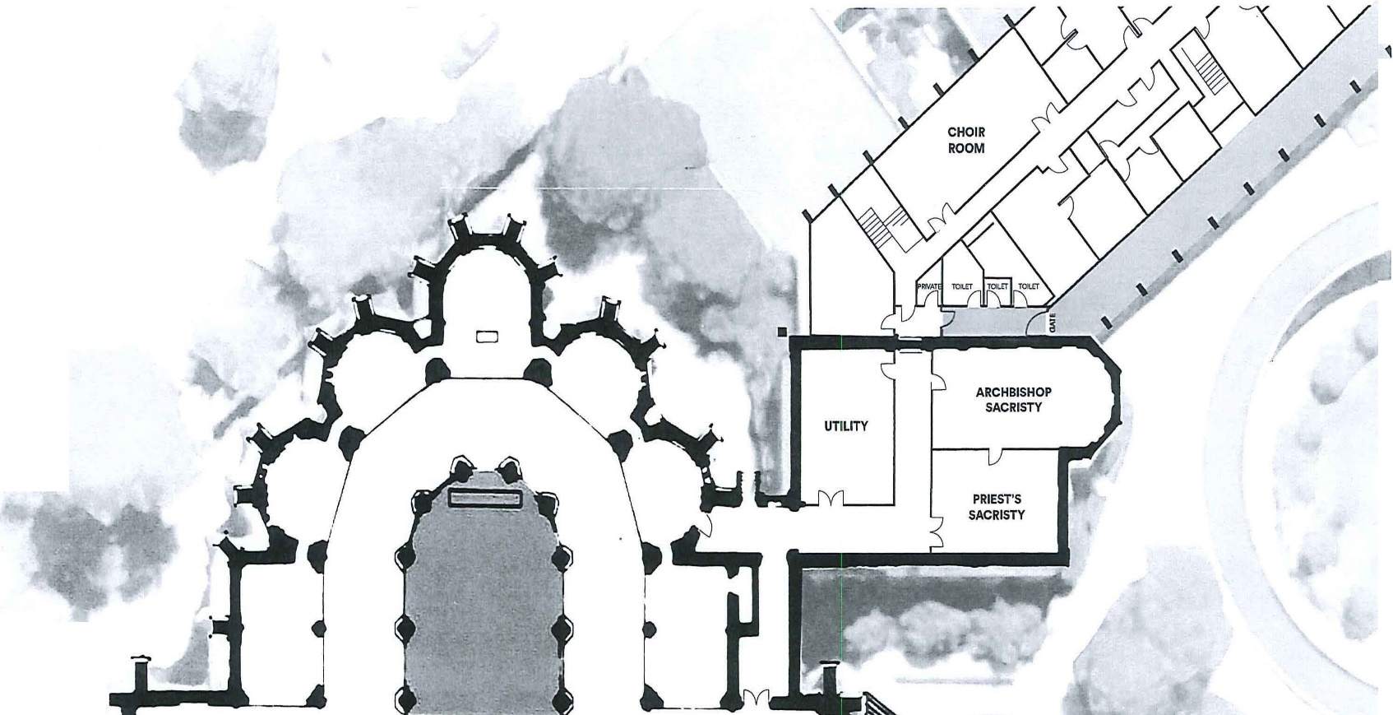
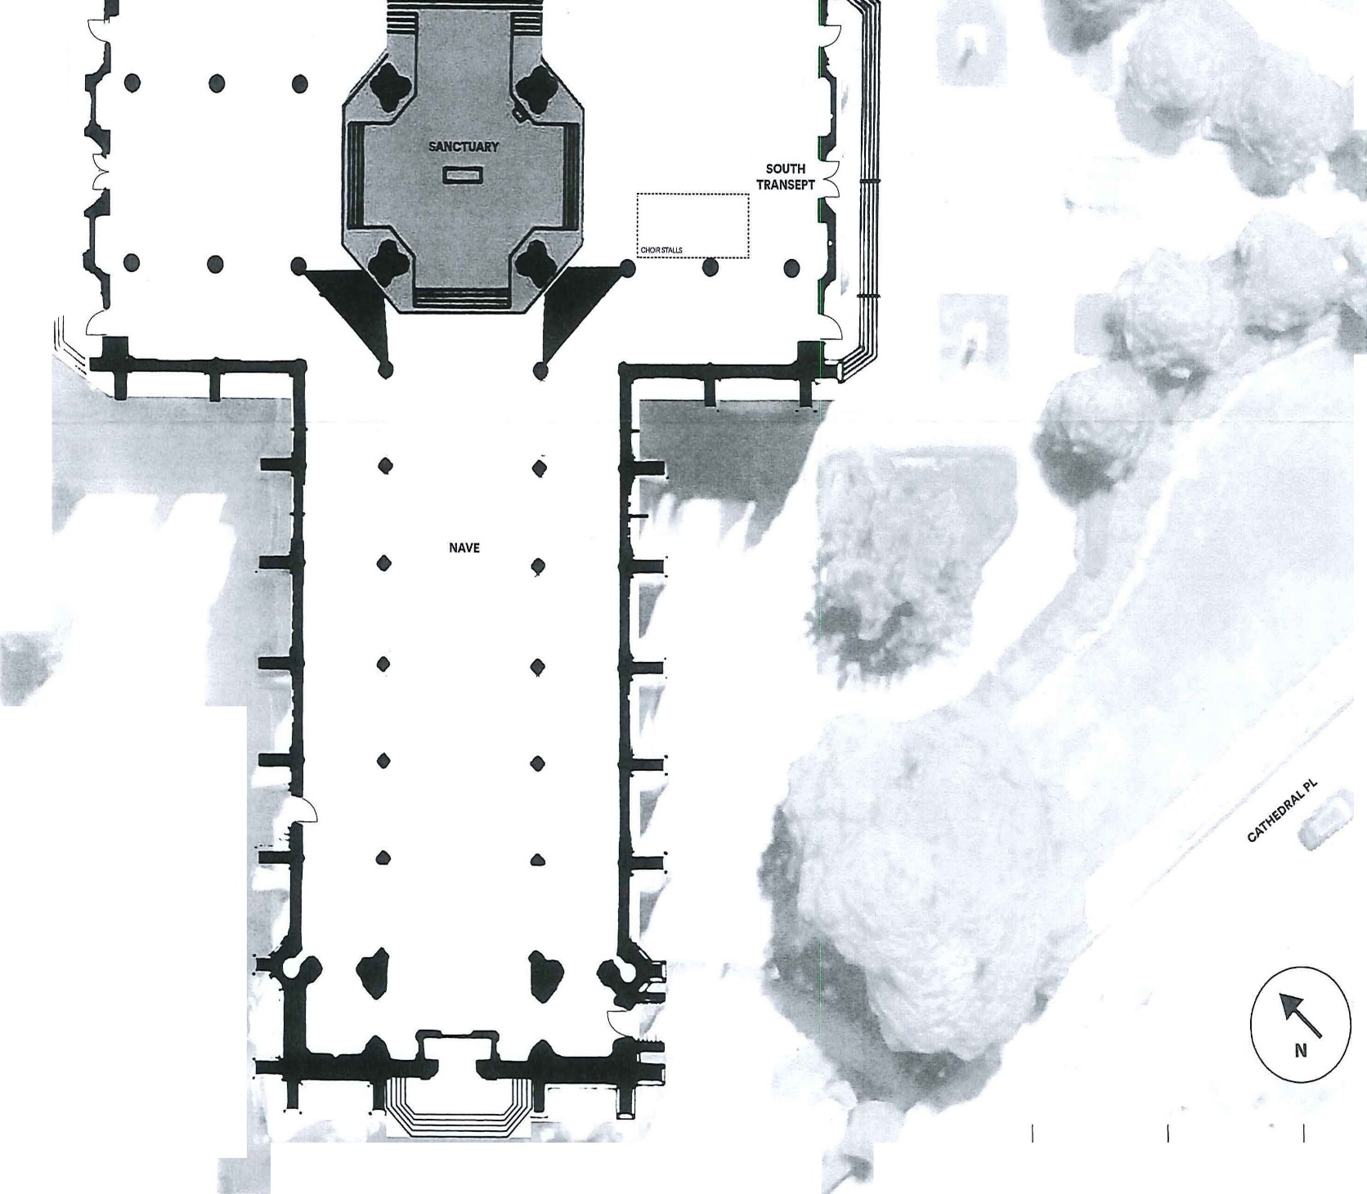

DPP v Pell [2019] VCC 260, [5]
Ibid [10].
Ibid [11].
Sections 210 and 217.

