

**Court of Appeal**

**GUIDE ON THE PREPARATION OF A**

**COMBINED FOLDER OF AUTHORITIES**

**30 September 2019**

**Format of index and documents to be included**

1. Annexure 1 is a sample index for a combined folder of authorities. The folder must contain copies of:
   1. all parties’ lists of authorities; and
   2. cases and legislation listed in **Part A** of each of those lists (see Practice Note SC CA 3 [15.2]).[1]
2. Cases and legislation listed in Parts B and C of the parties’ lists of authorities are **not** to be included.
3. The folder must be divided as follows (sections B, C and D can be amended or added to as appropriate, depending on the number of parties and the extent to which they rely on the same authorities and legislation):

|  |  |
| --- | --- |
| A. | All parties’ **lists of authorities** |
| B. | Part A authorities and legislation relied upon by **both the applicant and the respondent** |
| C. | Part A authorities and legislation relied upon by the **applicant only** |
| D. | Part A authorities and legislation relied upon by the **respondent only** |

1. Where a case is reported, the reported version must be included instead of an unreported version. If reported in an authorised report, the authorised report version must be used (see Practice Note SC CA 3 [15.7]).
2. Pinpoint references for all cases and legislation must be included in the index.
3. Cases and legislation, including pinpoint references, must be referenced in accordance with the current edition of the *Australian Guide to Legal Citation*.

**Hard copy combined folder of authorities**

1. All authorities must be printed without a watermark. They can be accessed through online sources such as Lexis Advance or AustLII (see Annexures 2 and 3 for guidance), or in print at the Law Library of Victoria.
2. All documents must be printed double-sided, however a document must not commence on the rear side of the previous document.
3. **Alphabetical tabs** which include a brief description must be inserted at the beginning of each section, and **numbered tabs** must be included to separate each document. The folder should not be paginated.
4. A hard copy combined folder of authorities is filed by delivering it to the Court of Appeal registry.

**Electronic copy combined folder of authorities**

1. The index and each document must be in separate electronic files, but all located in a single folder called “Authorities”.
2. Unless otherwise directed, the index file must:
   1. be in Word format;
   2. be hyperlinked to each other document (see the guide in Annexure 8 to the Registrar’s Note on the Preparation of Application Books); and
   3. commence with “0” in the file name (eg. “0. Combined folder index”).
3. Unless otherwise directed, all other files must:
   1. be in searchable PDF format and allow for text to be copied and pasted (see the guide in Annexure 6 to the Registrar’s Note on the Preparation of Application Books); and
   2. be named so that it commences with the number of the document according to the index (using “01”, “02” etc. for documents 1 to 9) and includes a very brief description (eg. “01. App list of authorities”, “02. Resp list of authorities”, “12. Howden (1937) 58 CLR 416”).
4. Unless otherwise directed, an electronic copy of a combined folder of authorities must be contained on a USB flash drive which is to be filed by delivering it to the Court of Appeal registry, not on RedCrest.

**ANNEXURE 1**

IN THE SUPREME COURT OF VICTORIA AT MELBOURNE

IN THE COURT OF APPEAL

CIVIL DIVISION

S EAPCI 20xx xxxx

BETWEEN

|  |  |
| --- | --- |
| [APPLICANT’S NAME] | Applicant |
|  |  |
| and |  |
|  |  |
| [RESPONDENT’S NAME] | Respondent |

**COMBINED FOLDER OF AUTHORITIES INDEX**

|  |  |
| --- | --- |
| Date of document: Filed on behalf of: Party’s or lawyer’s name and address: | Solicitor’s code:  DX: Tel: Fax: Ref: Attention: Email: |

**A. Lists of authorities**

1. Applicant’s list of authorities dated 30 September 2019
2. Respondent’s list of authorities dated 28 October 2019

**B. Part A authorities and legislation relied upon by both the applicant and the respondent**

1. *Defamation Act 2005* (Vic) ss 4, 22, 24-26
2. *Howden v Truth and Sportsman Ltd* (1937) 58 CLR 416, 419-425

**C. Part A authorities and legislation relied upon by the applicant only**

1. *Herald & Weekly Times Ltd v Popovic* (2003) 9 VR 1, [274], [306]
2. *Ainsworth v Burden* [2000] NSWSC 10, [6]

**D. Part A authorities and legislation relied upon by the respondent only**

Nil

**ANNEXURE 2**

To download the authorised or preferred version of a case on Lexis Advance, click **Download Document** (circled in red in the example below).

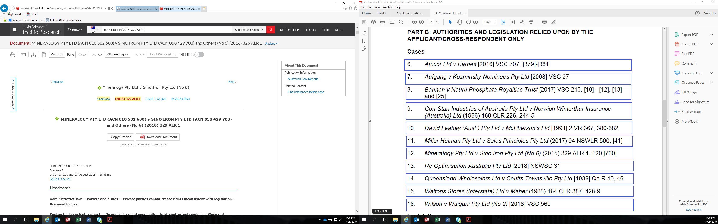

**ANNEXURE 3**

To save a case from AustLII in PDF format without a watermark, click **RTF format** in the **Download** menu on the right sidebar (circled in red in the example below), then save the document in PDF format using **Save As**, or print to PDF.

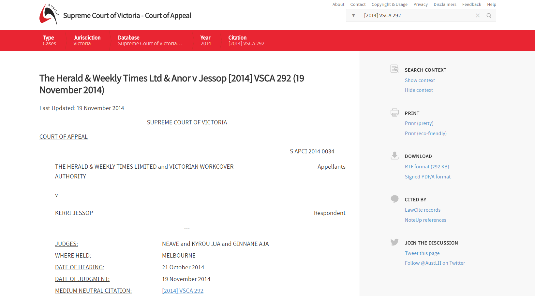

1. Part A of each party’s list of authorities comprises cases and legislation from which counsel intends to read. See Practice Note SC CA 3 [11.2].