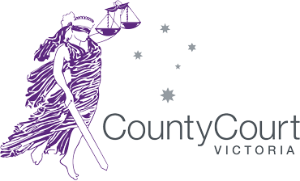
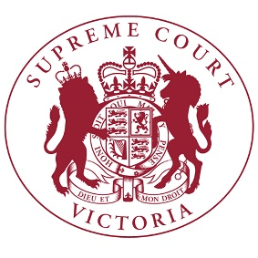
Jury Trials
STATEMENT FROM THE CHIEF JUSTICE OF THE SUPREME COURT AND CHIEF JUDGE OF THE COUNTY COURT
21 October, 2020

The Supreme Court and County Court (the Courts) are pleased to announce that, as the public health situation is improving, allowing the resumption of more activity within the community, a limited number of Melbourne-based criminal jury trials are planned to resume in a measured way from 16 November 2020.

The Courts had previously planned to resume trials on 20 July, but postponed that date in light of deteriorating public health conditions. The Courts will continue to monitor developments between now and 16 November and adjust the timeframe if that becomes necessary.

The Courts have undertaken extensive work to prepare for the safe resumption of jury trials. The Courts have consulted with health professionals, the legal profession and others involved with criminal trials. That planning has been informed by the resumption of jury trials in other States and other countries, but is based on the situation in Victoria.

Jury trials will resume with a range of measures in place including:

- avoiding the need for the physical gathering of large jury pools
- physical distancing arrangements within courtrooms and jury rooms
- the wearing of masks in accordance with current directions
- procedural changes to minimise the need for handling of objects
- frequent cleaning of high touch surfaces and other hygiene measures

Government has introduced modifications to jury procedures which support these measures.

Jury summonses will start to be sent to potential jurors in coming days. They will be accompanied by advice about the measures that will be in place and procedures for those whose personal circumstances may mean they ask to defer their jury service or be excused.

The Courts will continue to use technology for some other hearings to keep the number of people physically coming to court low and to accommodate the physical needs of criminal jury trials.

The Courts will closely monitor the resumption of jury trials with a view to the safety and wellbeing of all court users. Work is also progressing for the resumption of civil jury trials, and criminal and civil trials in regional areas.

Throughout 2020 the Courts have implemented measures to progress as many criminal cases as possible while jury trials have been suspended. The Courts will list criminal trials in 2021 commencing in the week of 11 January. The Courts will be limited in the number of trials that can be heard within existing buildings as a result of physical distancing requirements.

Quotes from Chief Justice Anne Ferguson and Chief Judge Peter Kidd:

“We look forward to the safe resumption of a number of criminal jury trials.”

“Jury trials will look a little different, but they will continue to fulfil their essential role in our criminal justice system.”

“Central to the work that has been undertaken has been ensuring that we can provide a safe and comfortable environment for jurors and all court users, consistent with measures being adopted across the community.”

“We wish to thank all those who have assisted in developing these plans and acknowledge in advance those who will attend for jury service. Jurors make an incredibly significant contribution through their participation in our justice system, representing the community and fulfilling an important civic duty.”

