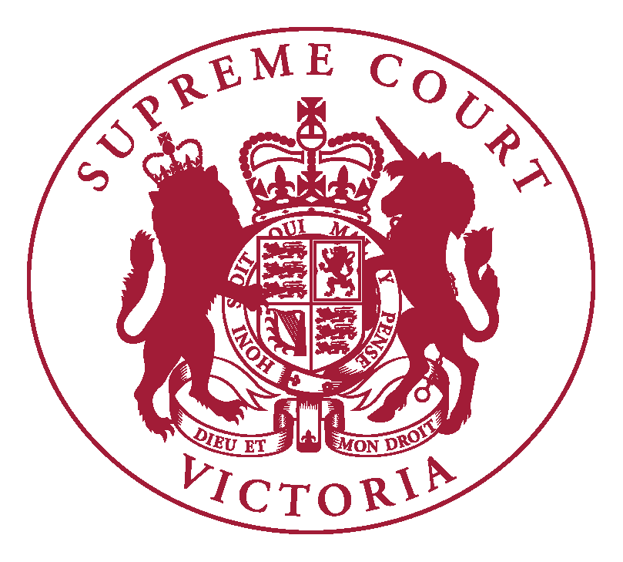

Supreme Court of Victoria
Practice Note SC Gen 21
Appearing in Court

INTRODUCTION
  - The Chief Justice has authorised the issue of the following Practice Note.
  - The purpose of this Practice Note is to clarify how parties and/or lawyers can advise the Court of their forms of address and pronunciation.

COMMENCEMENT
  - This Practice Note was issued on 31 March 2023 and commences on 3 April 2023 and will apply to all proceedings from that date.

PRONUNCIATION OF NAMES AND FORMS OF ADDRESS
  - The Supreme Court of Victoria is committed to treating all Court participants with equal dignity and respect.
  - Parties, lawyers and other participants are welcome to advise the Court of the phonetic pronunciation of names for use in a proceeding and forms of address (such as Ms, Mr, Mx). This includes but is not limited to counsel, solicitors, parties, witnesses, interpreters and entities.

  - Information regarding pronunciation and forms of address may be provided:
- on the Court’s appearance form or trial plan, by inserting the information in square brackets directly after a name;
- when announcing an appearance at the commencement of a hearing, when calling a witness or when mentioning a name relevant to the proceeding for the first time; or
- to an associate or other Court officer before a hearing or when requested by a judicial officer or associate during the hearing.
  - Legal practitioners are expected to know the correct pronunciation of all names associated with their client’s proceeding.

AMENDMENT HISTORY
31 March 2023: This Practice Note was issued on 31 March 2023.

Vivienne Mahy
Executive Associate to the Chief Justice
31 March 2023

