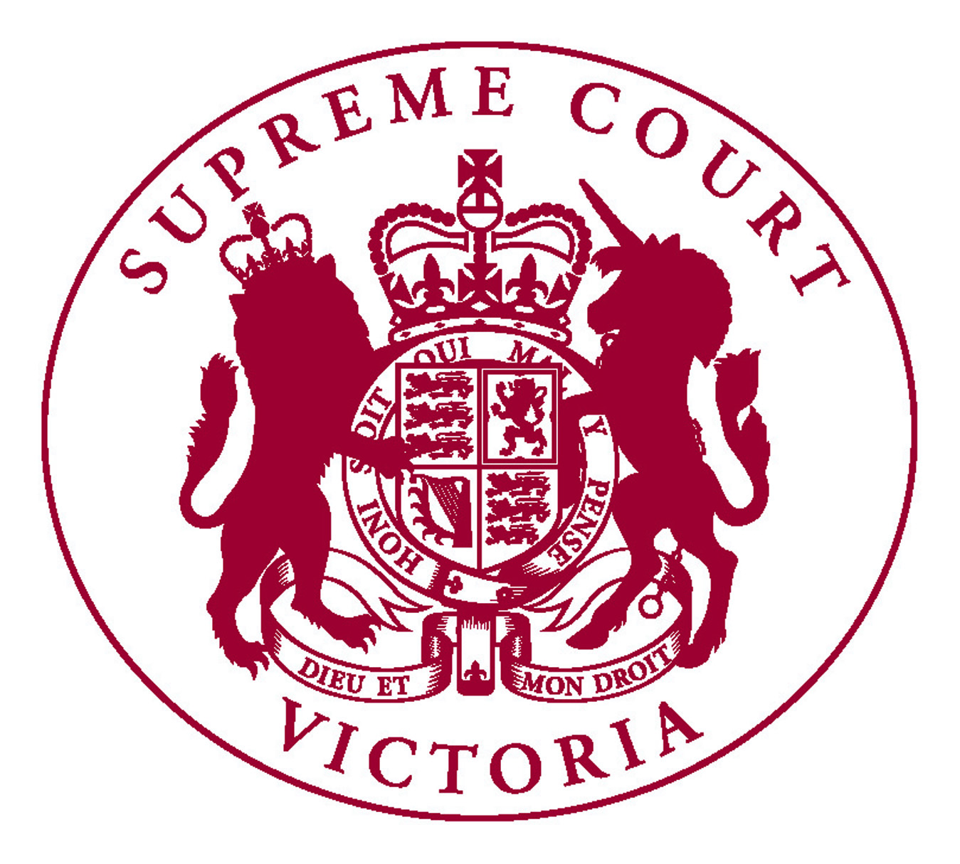

NOTICE TO PRACTITIONERS

VLRC SUCCESSION LAWS FINAL REPORT

In 2012, the Victorian Law Reform Commission was asked to review and report on the desirability of legislation or other reform in relation to certain succession law matters. The Report was tabled in Parliament by the Attorney General on 15 October 2013.

The Report contains 78 recommendations to reform the law and related practices that affect what happens to the assets of Victorians after they die. The complete recommendations can be found at www.lawreform.vic.gov.au. I have set out below those recommendations with greatest significance for the Supreme Court.

Witnessing Wills
The Commission considered carefully whether the current requirements for witnessing Wills should be revised to better protect older and vulnerable Will-makers. The Commission made no recommendations in this area. In balancing the risk of abuse with the ability of persons to make their own Will easily the Commission was of the view that the law should continue to facilitate Will-making rather than add additional obstacles to the process.

Statutory Wills
The Commission recommended only minimal changes in this area:
- an express provision that the Court may order separate representation for the person on whose behalf an application for a statutory Will is made (Rec 3); and
- repeal of the requirement to seek leave to make an application for a statutory Will (Rec 4).

Ademption
The Commission considered the law of ademption i.e. where a gift left in a Will is no longer owned by the Will-maker when they die. In such cases the gift is said to have been adeemed and the beneficiary receives nothing in its place. This is a particularly significant issue when a person acting under an enduring power of attorney (financial) sells an asset during the Will-maker’s lifetime and the Will-maker is unaware of the sale or no longer has the mental capacity to change their Will. A common example given by the Commission is when the family home, which may be specifically gifted under the Will, is sold to fund the Will-maker’s aged care.

The Commission considered that it is difficult to produce rules that accommodate all possible scenarios but it did recommended amendments to s 53 of the Guardianship and Administration Act 1986 and the Instruments Act 1958 to allow a beneficiary, whose gift might otherwise be adeemed, to avoid an unjust outcome (Rec 5 & 9).

It appears this will be a new type of proceeding in the Court, although it may be that similar factual circumstances in the past have led to different forms of proceeding being brought.

Intestacy
Setting a Limit on Next of Kin
Currently in Victoria there is no limit on the next of kin who are entitled to inherit on intestacy. The Commission has recommended that the limit should be set at the children of the deceased person’s parents siblings; i.e. first cousins (Rec 11 & 12).

Survivorship
The Commission considered there ought to be consistency with survivorship requirements under Wills. It has recommended that next of kin should be required to survive the deceased person by 30 days in order to inherit, unless the survivorship requirement would result in bona vacantia.

The Partner’s Share
Presently for the purposes of intestacy the Administration and Probate Act defines the deceased person’s partner as their spouse or domestic partner. Spouse means someone who was married to the deceased person at the time of the deceased person’s death. Domestic partner means either a registered domestic partner or an unregistered domestic partner. Registered caring partner is also defined but is not included in the definition of partner. The Commission has recommended that registered caring partners should be entitled to inherit on intestacy in the same circumstances as spouses and domestic partners (Rec 16 & 17).

The Partner’s Statutory Legacy
Amendments are recommended to the deceased partner’s statutory legacy upon intestacy in accordance with the recommendations of the National Committee for Uniform Succession adopted in NSW. The formula includes a statutory amount adjusted by CPI quarterly (Rec 18).

In harmony with the National Committee’s recommendations of 2005 the Commission choose $350,000 as an appropriate base amount at 1 January 2006. With changes to the CPI between December 2005 and the present, the adjusted statutory legacy now is $427,684.95.

The Commission recommends that the CPI adjusted amount be published quarterly by the Supreme Court on its website (Rec 19)

The Partner’s Right to Elect to Acquire Certain Property
Recommendations are made to broaden the ability of a partner of the deceased to elect to acquire an interest in property from a shared home to any estate property upon intestacy. The recommendations include a requirement to seek Court authorisation of an election where the property forms of a larger aggregate, and the acquisition could substantially diminish the value of the remainder of the property or make the administration of the estate substantially more difficult (Rec’s 23-28). The Commission recommended that there ought to be no right of election where the deceased person is survived by multiple partners (Rec 31).

Multiple Partners
The Commissions recommendations relating to the distribution of an intestate estate between multiple partners and children depart significantly from those of the National Committee for Uniform Succession Laws.

The Commission recommends that where the deceased person is survived by multiple partners and children or other issue the Administration and Probate Act 1958 should provide for the multiple partners share of the estate to be distributed:
(a) in accordance with a distribution agreement, or
(b) in accordance with a distribution order, or
(c) equally between the partners (Rec 29).

Per Stripes or Per Capita Distribution
Where next of kin take by representation the Commission has recommended that per capita distribution on intestacy should be abolished and per stripes distribution should be applied in all cases (Rec 34).

Taking Benefits into Account
In Victoria, some types of benefit received by the deceased person’s children during the deceased person’s lifetime must be taken into account when determining that child’s share on intestacy. This rule is referred to as the “hotchpot” rule. The Commission has recommended the abolition of the hotchpot rule (Rec 35).

Family Provision
The Commission recommends that the County Court have exclusive jurisdiction over family provision claims where the value of the net estate does not exceed $500,000 (Rec 37).

The Commission notes differing views about whether costs in the Supreme Court are greater than those in the County Court, but ultimately determined that exclusive jurisdiction was necessary to redress the traditional practice of bringing claims in the Supreme Court would remain. They considered that cordoning off a portion of family provision claims for the County Court to determine will build greater confidence in the County Court among members of the legal profession [6.46].

The Commission recommends replacing the current Victorian test for eligibility with the NSW test with the addition of step-children to the list of those eligible to make application (Rec 38).

The Commission recommends repeal of the existing cost provisions in the Administration and Probate Act 1958 in favour of a general provision that the Court may make an order that is in the Court’s opinion just and a non-exhaustive list of the types of order that can be made (Rec 41). It also recommended that there be a provision for capping costs (Rec 42).

The Commission made certain recommendations relating to formalising procedures which exist at present in the Court and to include certain practices from NSW (Rec 44). It is recommended that this be a co-ordinated effort by the Supreme and County Courts.

The County and Supreme Court should consider including in equivalent practice notes or rules of Court matters such as common position statements, pro forma affidavits, guidelines when a proceeding will be referred to judicial mediation etc.

The Commission declined to make recommendation to include “notional estate” as property of a deceased for the purposes of a family provision claim.

Executors’ Costs and Commission
A number of recommendations are made regarding what is acknowledged as a problem area. This includes a power of the Court to review and vary commission charges and disbursements claimed by executors and administrators out of estates based on section 86A of the Probate and Administration Act 1898 (NSW) (Rec 57).

This follows a recommendation made a number of years ago by the Court’s Probate Users’ Committee.

The Commission recommends that the Legal Services Commissioner be given jurisdiction to resolve a dispute between a legal practitioner and a beneficiary under a Will about an amount charged to an estate for executorial services, where the disputed amount does not exceed $25,000 (Rec 58).

It also recommended that review of legal costs by the Costs Court should once again be made available to a person interested in any property out of which a legal practitioner executor, administrator or trustee may recover legal costs (Rec 60). The Court’s submission noted that this power existed but has been removed, perhaps inadvertently, by amendments.

Payment of Debts
The Commission recognised that whilst not causing significant difficulties Victoria’s current law in relation to the payment of debts is overly complex. The Commission recommends the repeal of Part II of the Second Schedule (order of application of assets where the estate is solvent) in the Administration and Probate Act 1958 and the adoption of the model legislation recommended by the National Committee for Uniform Succession Laws (Rec 63).

The Commission also recommends that a provision be inserted into the Administration and Probate Act 1958 that stipulates that the payments of pecuniary legacies is to be made from the residuary estate.

Recommendations are made also with respect to insolvent estates and the interactions between the Bankruptcy Act and the payment of debts pursuant to the Administration and Probate Act 1958.

Small Estates
The Registrar of Probates, in defined circumstances currently provides a small estates service to members of the public. At one time this was a significant area of work for the Probate Office, however it has dropped off in recent years with only 48 matters dealt with last year.

The Commission recommends retention of this service and changes to the eligibility criteria raising the monetary limit to $100,000 indexed by CPI (Rec 67 & 68). The Commission acknowledges that this would require additional resources in the Probate Office. The Commission also recommends that the Court develop material to be made available on its website for those wishing to seek a grant of representation without legal assistance (Rec 69),

Informal Administration
The Commission noted that there is no statutory requirement to obtain a grant of representation after a death and indeed depending on the value of the estate assets there may be no real need to obtain a grant. The Commission sought to strike a balance between recognising the utility of informal administration and promoting formal administration by ensuring that a number of cheap and accessible options exist for obtaining a grant.

Recommendations made include the expansion of s32 of the Administration and Probate Act 1958 to any persons holding funds on behalf of a deceased person and a discharge of liability in respect of payments $25,000 or less adjusted quarterly to reflect CPI changes. The introduction of a sliding scale for the applicable fee for obtaining a grant in the Probate office, the repeal of Trustee Company elections and a strengthening of the provisions where State Trustees administer small estates under s79 of the Administration and Probate Act 1958.

MICHAEL J. HALPIN
Registrar of Probates
25 October 2013

