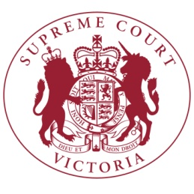
Notice to the Profession

The Chief Justice has authorised the issue of the following notice.

Double Sided Printing of Court Books and Books of Authorities

This Notice sets out the practice to be followed in the Supreme Court of Victoria (including the Court of Appeal) in respect of the form in which court books and books of authorities are to be printed.

On or after 30 January 2017, unless in the particular case the Court otherwise directs, each appeal book, court book and folder of authorities filed in hard copy shall be printed by the submitting party double-sided.

9 March 2017

Vivienne Macgillivray
Executive Associate to the Chief Justice

