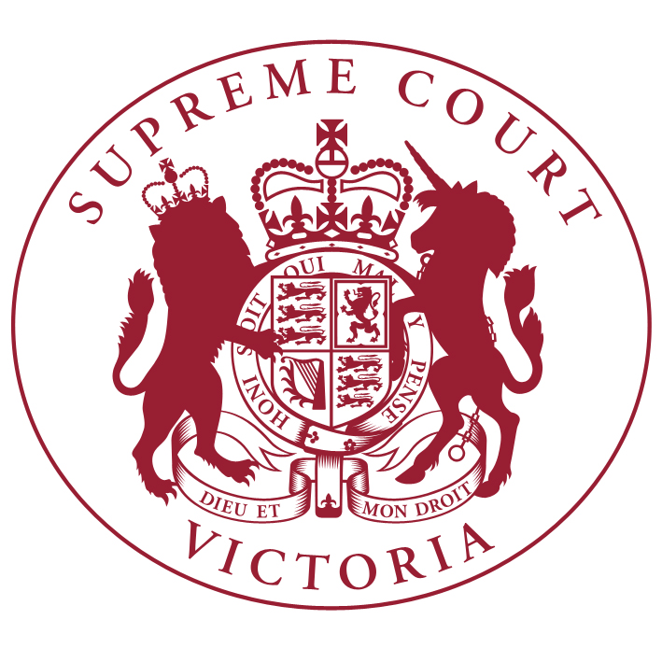
Practice Note No. 11 of 2015
Sentencing Hearings

- The Chief Justice has authorised the issue of the following Practice Note.
- This Practice Note will take effect in relation to matters listed for sentencing hearings on or after 1 March 2015, subject to any order of a judge.
- Practice Note No 3 of 2011 is revoked on that date.

Plea of Guilty

Listing and filing
- Where an accused pleads guilty to the charge or charges against them a date will be set by the Court for a sentencing hearing (hearing of the plea in mitigation) and notified to the parties.
- Material may be filed by email to criminaldivision@supremecourt.vic.gov.au or to the email address of the associate to the judge hearing the plea (where that is known).

Openings
- Unless otherwise ordered, the Crown is to file and serve no later than 10 days prior to the sentencing hearing the Crown opening on the plea.
- In addition to the factual circumstances of the offending the opening should include:
  - whether it is submitted that the offender is to be sentenced as a serious offender or a continuing criminal enterprise offender;
  - whether it is submitted that provisions imposing a minimum non-parole period are applicable (e.g. manslaughter in circumstances of gross violence intentionally or recklessly causing serious injury in circumstances of gross violence, manslaughter by single punch or strike, offences against an emergency worker on duty) and whether or not special reason should be found to exist;
  - whether any of the offences is a baseline offence; and
  - any orders which are sought by the Crown in addition to sentence (e.g. alcohol exclusion orders).
- Where any of the above matters is applicable, the Crown opening should include submissions regarding the matters said to support the application of the provisions and outline any evidence to be called in support of those matters.
- If an offence is a baseline offence the Crown is to address the following matters in its opening:
  - whether and for what reasons the offence is said to require a sentence at, above or below the baseline;
  - any relevant statistical material on which the Crown proposes to rely; and
  - any previous sentencing decisions on which the Crown proposes to rely whether by way of authority or comparison.

Victim Impact Statements
- The Crown is to ensure that any victim impact statements together with any attached medical reports, are filed and served no later than 5 days prior to the sentencing hearing.
- At the same time, the Crown shall provide to the Court and the Defence a letter indicating whether the statements are to be tendered in written form, read by the prosecutor, read by the victim or whether application will be made for them to be read by another person. The Crown should also indicate if application is to be made for alternative arrangements for the giving of evidence.
- Where it is proposed that a Victim Impact Statement or parts of a Victim Impact Statement are to be read aloud the Crown is to be mindful of the obligation on the Court under s 8Q(2) of the Sentencing Act 1991 to ensure that only admissible parts are read aloud.
- As soon as reasonably practicable after receiving a victim impact statement, the Defence must inform the Crown of any objections to the admissibility of all or any part of it.

Defence material
- The Defence is to file and serve no later than 5 days prior to the sentencing hearing:
  - any expert reports sought to be tendered;
  - any other documentary exhibits sought to be tendered; and
  - a list of any witnesses to be called.

Defence submissions
- If an offence is a baseline offence the Defence is to address the following matters in its submissions:
  - whether and for what reasons the offence is said to require a sentence at, above or below the baseline;
  - whether the statistical material provided by the Crown is accepted or whether the defence seek to rely on its own material; and
  - any previous sentencing decisions on which the Defence proposes to rely whether by way of authority or comparison.
- Where the Crown contends that a minimum non-parole period is applicable the Defence is to address the following in it submissions:
  - whether it is conceded that the relevant provisions apply or the basis on which is it said the Crown has failed to establish the application of the provisions; and
  - whether, and if so on what basis, special reason should be found to exist.

Resolution of issues prior to hearing
- Where there are any points of contention with the material provided, counsel are expected to confer prior to the day of the sentencing hearing.
- The Defence is to notify the Crown of any matters in dispute that would require the calling of evidence.
- The parties may request, or the Judge may require a preliminary hearing for the purpose of ruling on contested issues which may impact on the conduct of the plea.
- The Crown, in accordance with s 11 of the Victims Charter Act 2006, is to inform all victims about the process relating to the determination of an issue of admissibility of their victim impact statement.

Guilty verdict following trial
- Where an accused is found guilty of one or more charges at trial, the above procedure will apply with any necessary modification, subject to any order of the Trial Judge.

Vivienne Macgillivray
Executive Associate to the Chief Justice
27 February 2015

See Part 2A of the Sentencing Act 1991 encompassing provisions regarding serious sexual offenders, serious violent offenders, serious drug offenders and serious arson offenders.
See Part 2B of the Sentencing Act 1991.
Sentencing Act 1991 s 9B
Crimes Act 1958 ss15A and 15B
Sentencing Act 1991 s 9C
Sentencing Act 1991 s 10AA
Sentencing Act 1991 s 10A
Sentencing Act 1991 s 5A
See Division 4 of Part 4 of the Sentencing Act 1991
R v York [2014] VSCA 224

