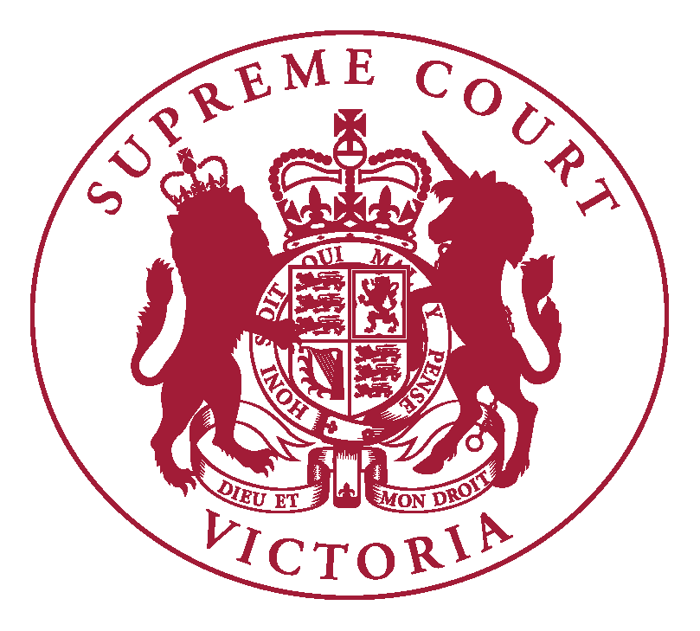

Supreme Court of Victoria
Practice Note No. 7 of 2016
Conditional Admission

INTRODUCTION

  - The Chief Justice has authorised the issue of the following Practice Note.

  - The purpose of this Practice Note is to describe the procedures to be followed in relation to applications for admission where the Victorian Legal Admissions Board has recommended in the compliance certificate in respect of a foreign lawyer that the foreign lawyer be admitted subject to conditions under s 20 of the Uniform Law.

  - This Practice Note commences on 1 April 2016 and will apply to all relevant applications on or after that date.

DEFINITIONS

  - References in this Practice Note to the Legal Profession Uniform Law have the same meaning as in the Legal Profession Uniform Law Application Act 2014 (Vic)

APPLICATION FOR ADMISSION

  - Pursuant to Rule 14.05 of the Supreme Court (Miscellaneous Civil Proceedings) Rules 2008 the Chief Justice directs as follows:
    - Where the Victorian Legal Admissions Board has recommended in a compliance certificate in respect of a foreign lawyer that the foreign lawyer be admitted subject to conditions, the application for admission is to be heard and determined by a single Judge of the Court.
    - The motion for admission may be made on a date advised to the applicant by the Prothonotary upon enquiry. The applicant should contact the Practice Court Coordinator (Common Law) by telephone on 9603 9288 or by email to practicecourt@supremecourt.vic.gov.au to be advised of the date of the hearing.
  - The applicant should inform the Victorian Legal Admissions Board of the date of the hearing.
  - The Victorian Legal Admissions Board will forward to the Court:
- the compliance certificate;
- the application made to the Victorian Legal Admissions Board for the compliance certificate;
- any statement of reasons by the Board regarding the conditions recommended.

RECORDING OF CONDITIONS

  - Where a person is admitted subject to certain conditions the Prothonotary shall indicate this in the Supreme Court Roll and maintain a record of those conditions.

APPLICATION FOR VARIATION OR REVOCATION

  - Prior to lodging an application for variation or revocation of a condition under s 20(3) of the Legal Profession Uniform Law, the applicant should seek a recommendation from the Victoria Legal Admissions Board.
  - Any application for variation or revocation shall be made in accordance with the ordinary Rules of Court and will ordinarily be made returnable before a single Judge of the Court.
  - The applicant should notify the Victorian Legal Admissions Board of the date for hearing of the application.
  - Any recommendations of the Victorian Legal Admissions Board are to be produced in evidence to the Court.
  - The applicant’s admission file will be produced to the Court by the Prothonotary for the hearing of the application.
  - If the Court varies or revokes a condition, the Prothonotary shall amend the Supreme Court Roll accordingly and shall maintain a record of the order the applicant’s admission file.

Viv Macgillivray
Executive Associate to the Chief Justice
18 March 2016

