Supreme Court of Victoria
Practice Note SC CA 2
Interlocutory applications and reserved questions of law in criminal proceedings

INTRODUCTION
  - The Chief Justice has authorised the issue of the following Practice Note.
  - The purpose of this Practice Note is to outline the procedure to be followed in relation to interlocutory appeals and the reservation of questions of law pursuant to Divisions 4 and 5 of Part 6.3 of the Criminal Procedure Act 2009. An interlocutory appeal may only be commenced in relation to an interlocutory decision.
  - This Practice Note is to be read in conjunction with Order 3 of the Supreme Court (Criminal Procedure) Rules 2008.
  - For ease of reference a flowchart setting out the Court of Appeal’s process for hearing interlocutory applications is attached as Annexure 1.

COMMENCEMENT
  - This Practice Note was issued on 30 January 2017 and applies to all interlocutory applications and reserved questions of law in criminal proceedings commenced on or after that date.
  - This Practice Note replaces Court of Appeal Practice Statement No. 1 of 2016 which is hereby revoked.

DEFINITIONS
  - In this Practice Note:
CPA means the Criminal Procedure Act 2009.
Rule or Rules means the Supreme Court (Criminal Procedure) Rules 2008.

CONTACTING THE COURT OF APPEAL REGISTRY
  - The intending applicant in an interlocutory appeal should contact the Registry as soon as is reasonably practicable following the Judge’s decision in relation to certification. This contact may be made, either by telephone or by email to coaregistry@supcourt.vic.gov.au, prior to the formal commencement of the interlocutory appeal, and will enable the Registry to initiate preparations for the interlocutory appeal by taking actions such as requesting the relevant transcript from VGRS.
  - At the time of contacting the Registry, the intending applicant should notify the Registry of the following particulars:
    - the name of the Judge who made the interlocutory decision;
    - the name, contact details and availability of trial counsel for the applicant and respondent;
    - the date on which the Judge ruled on the application for certification;
    - the status of the trial proceedings;
    - whether the applicant is in custody and, if so, whether the applicant wishes to attend the interlocutory appeal hearing;
    - a realistic estimate of the time required for oral submissions in regard to the interlocutory appeal (bearing in mind that the application for leave to appeal or review may be treated as the hearing of the appeal); and
    - the nature of any material or documentation tendered or referred to in submissions before the Judge regarding the interlocutory decision.

INTERLOCUTORY APPEALS
  - Practitioners are reminded that the Court may only give leave to appeal where satisfied that it is in the interests of justice to do so, for example, where the determination of an appeal against an interlocutory decision may render the trial unnecessary; substantially reduce the time required for the trial; resolve an issue of law, evidence or procedure that is necessary for the proper conduct of the trial; or reduce the likelihood of a successful appeal against conviction in the event that the accused is convicted at trial.
  - Further, the Court must not give leave to appeal after the trial has commenced, unless the reasons for doing so clearly outweigh any disruption to the trial.

COMMENCEMENT OF AN INTERLOCUTORY APPEAL WHERE THE INTERLOCUTORY DECISION HAS BEEN CERTIFIED BY THE TRIAL JUDGE
  - If the Trial Judge certifies an interlocutory decision in accordance with s 295(3) of the CPA, an interlocutory appeal may be commenced by filing a Notice of Application for Leave to Appeal Against Interlocutory Decision.
  - The Notice shall be signed by the applicant or the applicant’s legal practitioner and be filed electronically if practicable. All electronic filing is to be by email to coaregistry@supcourt.vic.gov.au.
  - The Notice must be filed in accordance with the timeframe prescribed by s 298(1) of the CPA, being:
    - subject to paragraph (b), if the trial has not commenced when the interlocutory decision is made, within ten days after the day on which the interlocutory decision is made or any extension of that period granted under s 313; or
    - if the trial commences within ten days after the day on which the interlocutory decision is made, within two days after the day on which the trial commences or any extension of that period granted under s 313; or
    - if the trial has commenced when the interlocutory decision is made, within two days after the day on which the interlocutory decision is made or any extension of that period granted under s 313.
  - The applicant must serve a copy of the Notice on the respondent in accordance with s 298(2) of the CPA. The Registry will not serve the Notice on the respondent.

COMMENCEMENT OF AN INTERLOCUTORY APPEAL WHERE THE JUDGE HAS REFUSED TO CERTIFY AN INTERLOCUTORY DECISION
  - If the Trial Judge refuses to certify an interlocutory decision in accordance with section 295(3) of the Act, an interlocutory appeal may be commenced by filing a Notice of Application for Review of Refusal of Judge to Certify.
  - The Notice shall be signed by the applicant or the applicant’s legal practitioner and be filed electronically if practicable.
  - Pursuant to s 296(4) of the CPA, on a review, the Court of Appeal—
    - must consider the matters referred to in s 295(3); and
    - if satisfied as required by s 297, may give the applicant leave to appeal against the interlocutory decision.
Accordingly, in addition to filing a Notice of Application for Review of Refusal of Judge to Certify, the applicant should also file a Notice of Application for Leave to Appeal Against Interlocutory Decision when commencing an application for review.
  - The Notices must be filed in accordance with the timeframe prescribed by section 296(2) of the CPA, being:
    - subject to paragraph (b), if the trial has not commenced when the Judge refuses to certify, within ten days after the day on which the Judge refuses to certify or any extension of that period granted under s 313; or
    - if the trial commences within ten days after the day on which the Judge refuses to certify, within two days after the day on which the trial commences or any extension of that period granted under s 313; or
    - if the trial has commenced when the Judge refuses to certify, within two days after the day on which the Judge refuses to certify or any extension of that period granted under s 313.
  - The applicant must serve a copy of both the Notice for Leave to Appeal Against Interlocutory Decision and Notice for Review of Refusal of Judge to Certify on the respondent in accordance with s 296(3) of the CPA. The Court of Appeal Registry will not serve either notice on the respondent.

LISTING
  - The Registrar will determine the urgency of an interlocutory appeal and make suitable arrangements to list the matter for hearing.
  - The Registrar will not delay listing an interlocutory appeal on the basis of the applicant obtaining advice as to the merits of the interlocutory appeal.
  - It is expected that trial counsel, wherever practicable, will appear at the hearing of an application for leave or review.
  - Upon listing an interlocutory appeal, the Registrar will notify the Trial Judge as to the listing date.

SUMMARY OF CONTENTIONS
  - In each interlocutory appeal the Registrar will give directions for the filing of documents and fix dates by which such documents are required to be filed and served.
  - Unless actually directed to do so no affidavit in the form specified in Rule 3.05 will be required to be filed and served. Instead of requiring such an affidavit the Registrar will usually direct that the parties file an agreed document setting out a succinct narrative history of the conduct of the matter to date.
  - The Registrar will ordinarily direct each party to file and serve a Summary of Contentions and will specify dates by which the respective Summaries of Contentions are to be filed and served. Ordinarily the applicant will be directed to file and serve first.
  - A Summary of Contentions should:
    - outline the contentions relied upon in argument before the Judge prior to the making of the interlocutory decision;
    - separately outline any additional contentions sought to be relied upon; and
    - refer to relevant authorities.
  - A Summary of Contentions is not required to include a summary of facts.
  - Unless otherwise directed by the Registrar, a Summary of Contentions should not exceed five pages in length.

TRANSCRIPT
  - The Registry will obtain the transcript of the submissions before the Judge in relation to the interlocutory decision and the Trial Judge’s decision and, where required, the transcript in relation to certification. Copies of the transcript will be provided by the Registry to the parties.

FILING OF DOCUMENTATION OR MATERIAL TENDERED OR REFERRED TO IN SUBMISSIONS BEFORE THE TRIAL COURT IN REGARD TO THE INTERLOCUTORY DECISION
  - The Registrar will obtain and provide to the parties a copy of all relevant documentation or material referred to in submissions before the Trial Judge relating to the interlocutory decision. Usually these documents will be obtained in an electronic format from the associate to the Trial Judge so as to expedite the process of preparing the interlocutory appeal for hearing.

AUTHORITIES
  - A party should file and serve a List of Authorities, which are expected to be referred to during the hearing of the interlocutory appeal, as soon as practicable.
  - Authorities referred to in a List of Authorities, if reported in an authorised series of law reports, are to be cited by that citation.
  - The party concerned is not required to file copies of the authorities, whether reported or unreported, unless directed to do so.

ELECTRONIC FILING
  - Electronic filing is the Registry’s preferred method of filing. Documents to be filed electronically should be emailed to: coaregistry@supcourt.vic.gov.au.
  - Where documents are filed electronically, it is not necessary to file a hard copy.
  - Documents filed in electronic form are required to be filed in Word, or searchable PDF format. Statements of Contention must be filed in an editable format which allows for copying of parts of any such document.

ABANDONMENT
  - An interlocutory appeal may be abandoned at any time before the hearing of the appeal by filing with the Registrar a notice of abandonment.
  - To avoid wasted preparation by the Court, the parties are to advise the Registry as soon as a decision is made to abandon an interlocutory appeal or review.

RESERVED QUESTIONS OF LAW
  - In general, and making allowance for their different nature, the Registrar will manage reserved questions of law, or the refusal to certify a question of law, pursuant to sections 302 and 304 of the Act in accordance with this Practice Note, and, in the case of a refusal to reserve a question of law, Part 4 of Order 2 of the Rules.

CONTACT
  - The contact details of the Registry are:
Address: Level 1
436 Lonsdale Street
Melbourne VIC 3000

Telephone: (03) 9603 9100
Fax: (03) 9603 9111

Email: coaregistry@supcourt.vic.gov.au

Hours: 9.30am – 4.00pm, excluding public holidays and the Tuesday following Easter Monday

AMENDMENT HISTORY
30 January 2017: This Practice Note was issued on 30 January 2017 and replaced Practice Note No 1 of 2015

Vivienne Macgillivray
Executive Associate to the Chief Justice
30 January 2017

ANNEXURE 1
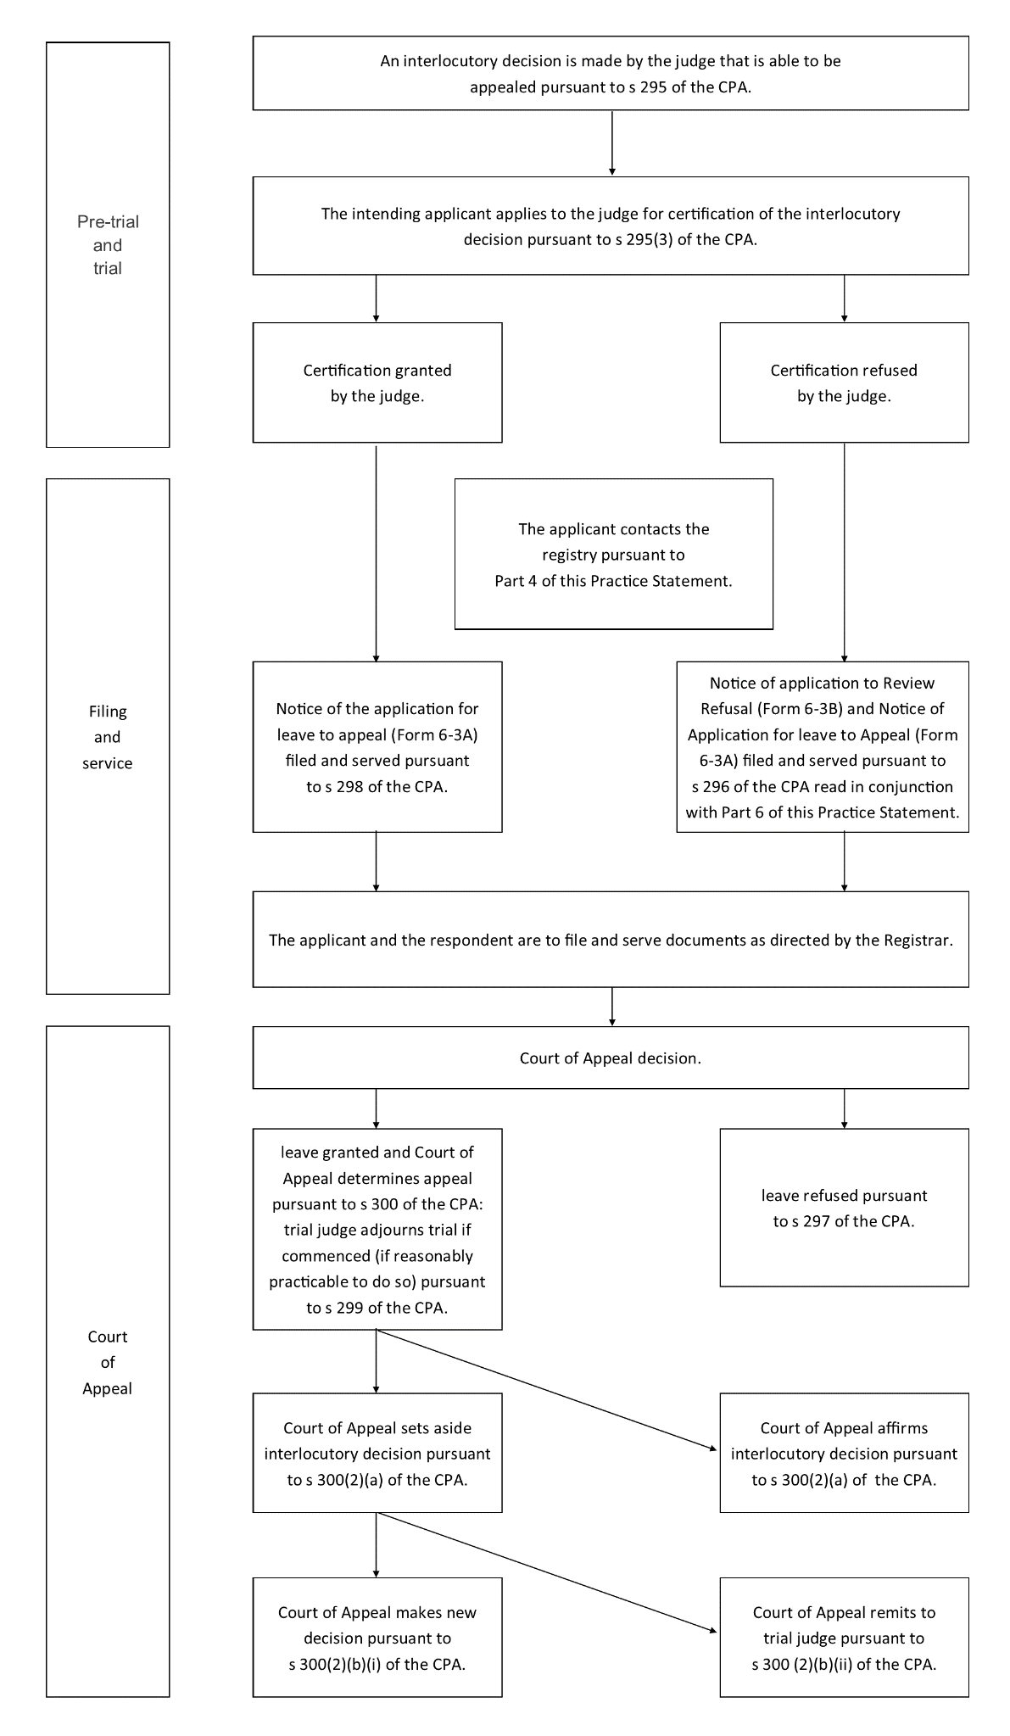

As defined in s 3 of the CPA.
See s 295(3) CPA
Section 297(1)(b) CPA
Section 297(2) CPA
Form 6-3A as prescribed in the Rules.
Form 6-3B as prescribed in the Rules.
Ibid.
Form 6-3A.
Form 6-2N as prescribed in the Rules.

