Speech for the Honourable Justice Marilyn Warren AC

Chief Justice of Victoria

The Hon Justice Pamela Tate

Court of Appeal, Supreme Court of Victoria

Farewell Breakfast hosted by the
Women Barristers’ Association and
Victorian Women Lawyers,
Melbourne

Thursday, 14 September 2017

I am delighted to have been invited to pay tribute to the Honourable Justice Marilyn Warren AC, Chief Justice of the Supreme Court of Victoria.
On a personal note this gives me an opportunity, as one of Marilyn’s judges, to publicly thank her for what she herself has described as ‘the feminisation of the Supreme Court’. The Court was once an old and crusty institution, full of, dare I say it, old and crusty men, attached to archaic procedures and pompous hierarchies. Marilyn has been responsible, practically single-handedly, for the transformation of the Court to a modern efficient organisation that is welcoming to women, both as judges and as lawyers. Women in the law in Victoria owe Marilyn an enormous debt.
I have chosen to focus this morning upon her Honour’s achievements in transforming the Supreme Court as an institution from its conservative base to the women-friendly organisation it now is. Jenny Batrouney will focus upon Marilyn’s impact upon women in the profession.
As I am sure all of you here are aware, institutional change is not for the faint hearted. Marilyn brought to this task her intellect, her steely determination, and her warmth.
Marilyn arrived at the Court in 1998 having already had a long and distinguished career in the law.
Her beginnings were as a young lawyer in government. Access to the profession for women at that point was not easy. She was the first woman to gain articles of clerkship in the Victorian public service. She did her articles with the Solicitor to the Public Trustee, in an office of 10 solicitors, all of them male. As a first-year solicitor, in 1976 she was refused a position in the Crown Solicitor’s Office because ‘it was deemed that women should not be confronted with the details of nasty crimes’.
The irony of this can hardly be overstated given that Marilyn went on, some 25 years later, to preside over a multitude of criminal trials and appeals including amongst the worst criminal offending in Victoria for murder, rape, incest, and terrorism. No longer are women restricted in their goals by the ostensible aim of protection.
Marilyn was, as ever, resilient in response to the Crown Solicitor. She persisted and became Assistant Chief Parliamentary Counsel in 1984. The expertise she gained by the exactitude required in drafting legislation well prepared her for issues on statutory interpretation for the rest of her career.
Marilyn signed the Bar roll in 1985. She quickly established herself in commercial, administrative and planning law. By the time I arrived at the Bar in 1991, Marilyn was one of the few leading women counsel to be seen in the courts. I recall sitting very quietly in the back pews of what felt like a large courtroom seeing Marilyn on her feet, brandishing the Trustee Act and displaying full intellectual control of the argument. I wondered who she was and whether I could ever achieve that degree of ease or dominance in a court.
No one was surprised when she took Silk in 1997.
When Marilyn joined the Court in 1998 there was only one other woman judge. That was the Honourable Rosemary Balmford, the first woman judge appointed to the Supreme Court since it was founded in 1852. It would be true to say that at that time the Court was a conservative institution, well intent on administering justice according to law, but attached to decades-old practices and procedures and displaying a near-uniform sense of masculine authority. Marilyn did what she was renowned for — working without limit — to enhance the reputation of the Court’s Commercial List.
As a judge, Marilyn maintained a dignified and courteous presence on the bench. She ‘very quickly became known as an excellent trial judge, who [ran] a very pleasant and efficient court.’
She was the Judge-in-Charge of the Commercial List for over two and a half years. At times this involved managing a vast array of matters at different stages in the process of litigation. She was determined to remodel the Supreme Court into the venue of choice for commercial litigators. This was at a time when commercial litigation was drifting to New South Wales or the Federal Court. Marilyn stopped that flow in its tracks. Soon everyone wanted to have their matter heard in the much-heralded ‘fast track’ of Victoria’s Commercial List.
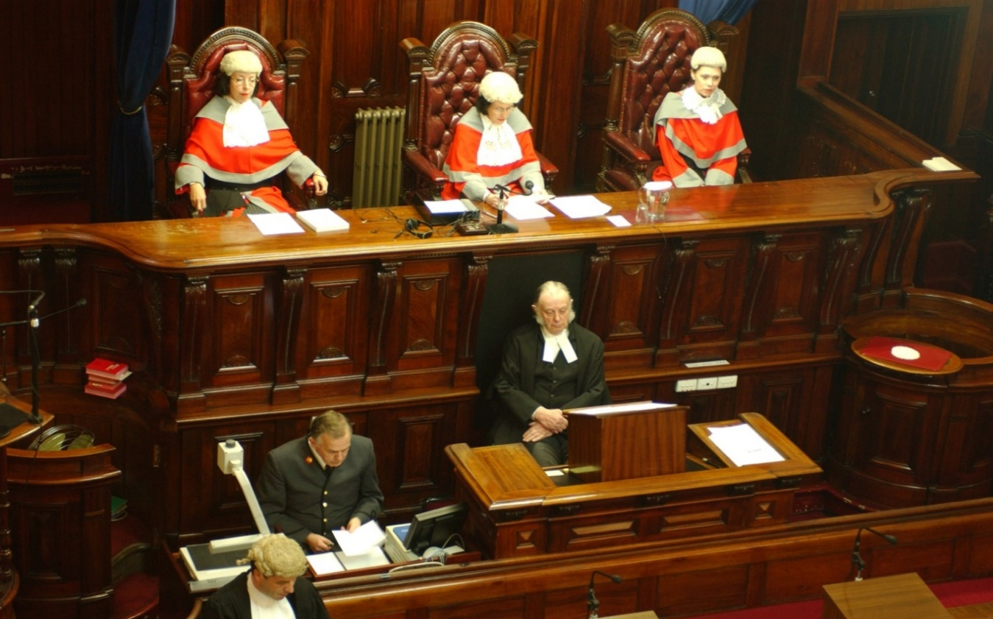
Another woman, Justice Julie Dodds-Streeton, joined the Court in 2002. Almost immediately an all female Full Court was convened to sit on an admissions ceremony.

The historic status of the event was captured by The Age, the Victorian Bar News and the Law Institute Journal as the first occasion of its type in the Court’s 150 year history.
Rosemary presided, with Marilyn to her right and Julie to her left. Even now, more than 15 years later, those photographs are a moving reminder of the beginning of change in the Court and the opportunities that were gradually being presented to senior women in the profession.
In 2003 Marilyn became Victoria’s 11th Chief Justice.
As we are all aware, Marilyn was the first woman to be appointed Chief Justice in the Supreme Court’s history. She was the first woman appointed to that office in any State or territory in Australia.
This was an extraordinary shift in thinking.
It may be difficult to appreciate now but the appointment of a woman to lead what was seen as a traditional institution, devoted to stability and certainty in the resolution of disputes, was an upheaval. It was a recognition, as the then Attorney-General said, of the need at that time to ‘lift the curtain of invisibility, of direct and indirect discrimination, of baseless assumptions, paternalism and the invidious and territorial fear of difference that greet[ed] women at the door of the profession.‘
Appointments of women were a means of ‘ensuring that, where women were overlooked in the past because of this invisibility, they are considered — on their merits as competent and capable professionals, and on an equal footing with their male colleagues’.
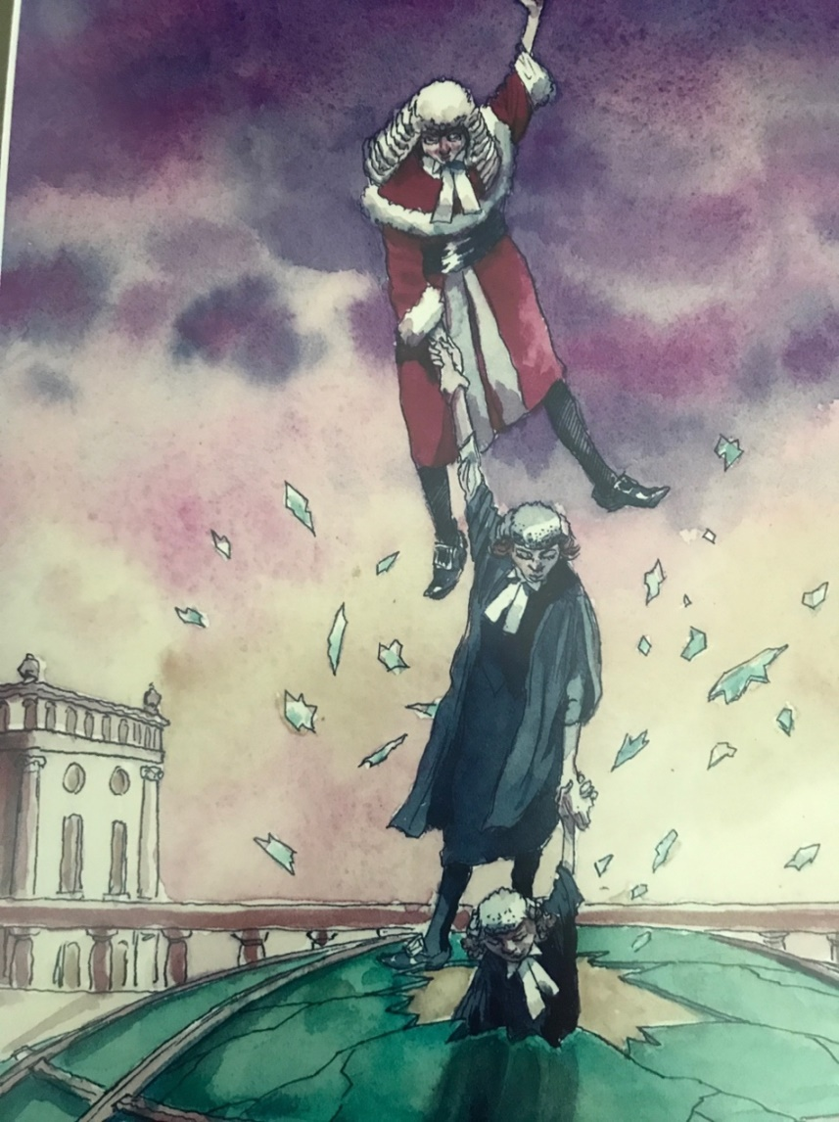
At the time The Age depicted Marilyn as crashing through the glass ceiling. In the illustration by John Spooner, Marilyn is seen holding the hand of another woman, probably younger and probably a barrister, who has also crashed through the glass ceiling. That woman in turn is holding the hand of another woman practitioner who is making her way through the glass ceiling.
The Honourable Margaret McMurdo, the retired President of the Queensland Court of Appeal, treasures the original of this illustration given to her by a friend, a copy of which she sent for this event.
There could be few illustrations which so accurately predicted what is one of Marilyn’s legacies — the capacity to inspire, and, at times, persuade, other women to occupy positions of leadership in the legal profession.
It also adverts to her capacity to make connections with other women lawyers, to undertake what she has described as ‘cross-generational promotion’ where women in the profession take an active role in nurturing more junior women, providing ‘links in the chain, made by the helping hand of our role models and mentors’.
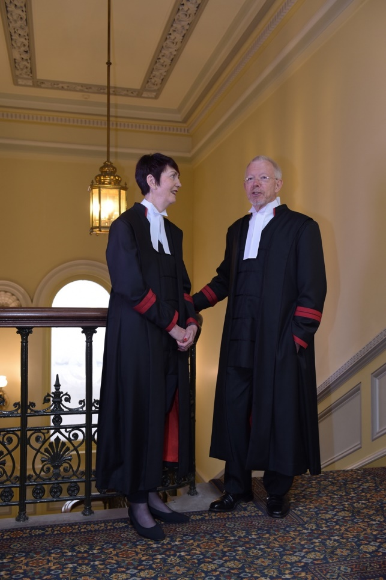
The picture also serves as a reminder of the modernisation of the Court that has occurred under Marilyn’s leadership. Marilyn is depicted wearing a long-bottomed ceremonial wig, the red winter robes, complete with fur and a black cummerbund around her waist. The wig is a sign of times past. Marilyn has in recent years abolished the wearing of all wigs, in trials and appeals. Wigs are also abolished for ceremonial purposes because, as Marilyn remarked, in ceremonies the community should see us at our most accessible. Marilyn has replaced the winter robes, representative of the fussy heaviness of a bygone era, with a simple contemporary look.
There has been a move away from the exclusive appearance of an old boys’ club, with garments intended for the male body shape, in all its guises, to an easy-to-wear sleek practical gown fit for all purposes and accommodating the male and female form alike.
The woman judge happily modelling the new robe is Justice Anne Ferguson, our new Chief Justice who will follow so admirably in Marilyn’s footsteps and protect her legacy.
Over the 15 years since the all-female bench at the admission ceremony, a further 15 women have been appointed as judges of the Supreme Court. This includes four women who have been appointed to the Court of Appeal.
There are presently 11 women judges on the Court. This is out of a total of 44 judges. In addition, there are now three women associate judges and four women judicial registrars. These are real milestones towards establishing ‘judicial equality’.
Unfortunately, the convening of an all-woman bench remains a rarity. I have had only two experiences of sitting on such a bench, both in civil appeals. The first was in August 2011 when I sat with the Chief Justice and Justice Karin Emerton on a planning appeal.
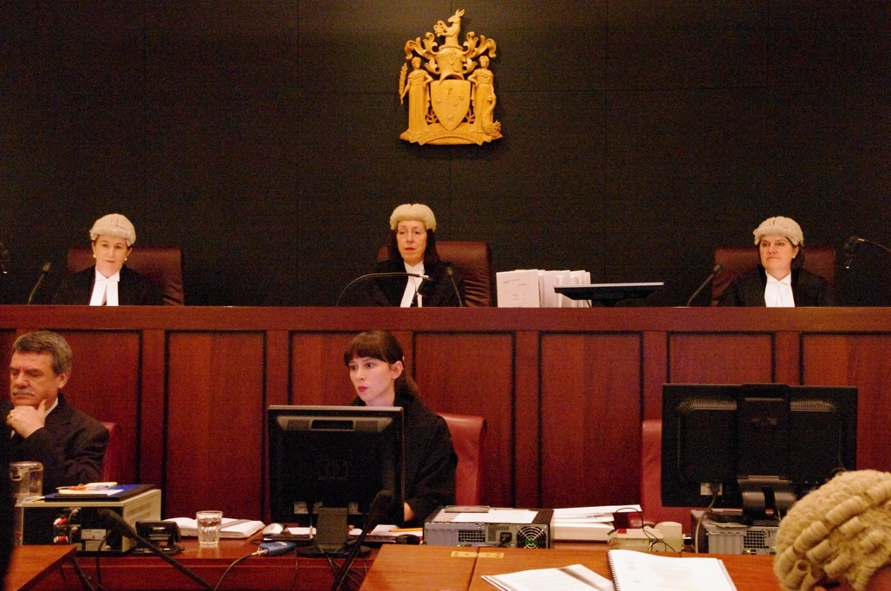
I believe this was the first occasion on which an all-female Full Court sat after the admission ceremony in 2002.
The next occasion was in November 2015 when I sat with the Chief and Justice Anne Ferguson in a property dispute.
To my knowledge, there has not been as yet an all-female Full Court that has heard a criminal

appeal. That is an achievement that awaits Anne’s stewardship.
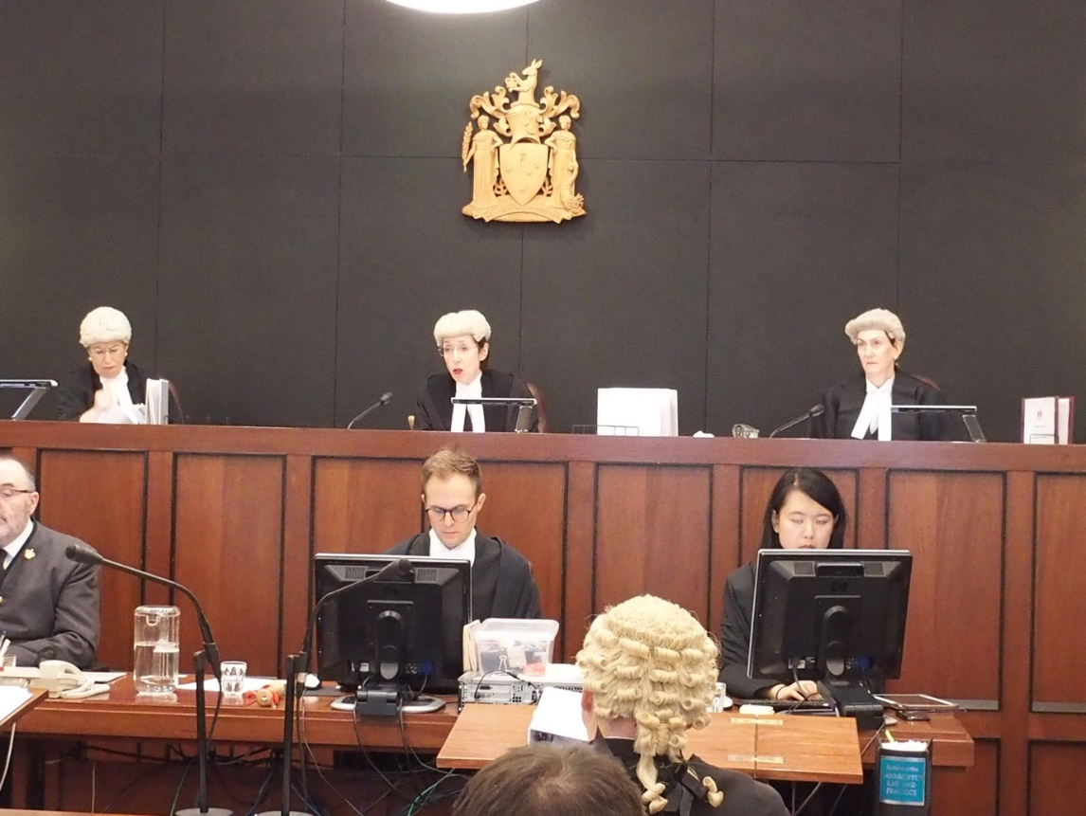
But the ‘feminisation of the Court’ for which Marilyn is responsible is not only about numbers.
It is also about organisational change. It is about making the judicial environment one in which women are supported to be confident and comfortable in the performance of their judicial duties. It is about gaining, and retaining, the confidence of male colleagues.
Lady Brenda Hale, who was recently appointed the first female President of the United Kingdom Supreme Court, has said that
[T]he best women leaders bring a warmth, a lightness of touch and a lack of pomposity to the judiciary without in any way sacrificing the seriousness with which the work is done. The challenge lies in bringing fellow justices on board with the aim of making the court a collegiate and happy place in which to discharge our grave responsibilities.
Lady Hale has observed Marilyn at close quarters when visiting Melbourne. She goes on to say, ‘From all that I have seen of her, Chief Justice Warren has risen splendidly to that challenge’.
Making the court a collegiate and happy place, and bringing fellow justices on board, has been one of Marilyn’s central aims.
There is respect for the autonomy and leadership of others with judge managed specialist lists.
As part of the aim of securing cultural change within the Court, judges have been encouraged to ‘find ways to dilute, vary and soften the impact of the adversarial setting’. Technology has been embraced.
As a means of achieving her vision of a single unified court, Marilyn encouraged a system by which Trial Division judges occasionally sit on appeals, and vice versa. This has placed less emphasis on hierarchies. It has deepened the sense of collegiality within the Court as a whole. It has contributed to the high sense of morale.
These measures have streamlined and modernised the service the Supreme Court offers to the people of Victoria, while retaining the respect and authority it enjoys as an equal arm of government charged with upholding the rule of law. It has created an environment in which women judges can thrive.
As can be expected, the cultural change has also enabled male judges to flourish. I have stopped counting the number of times male judges relate to me how much happier the Court is as an institution ‘under Marilyn’.
Marilyn initiated the use of social media to communicate with the profession, and the community. For a court to do this is probably a world first.
But then Marilyn is keen on world firsts.
For thirteen years she has chaired the Judicial College of Victoria. Its ambition under Marilyn is to be nothing less than akin to a judicial university. It offers seminars on law and literature, indigenous reconciliation, and hosts High Court justices to speak on the Constitution and State Courts. It investigates what promotes well-being in the judicial environment. The Honourable Susan Denham, formerly Chief Justice of Ireland, who describes Marilyn as ‘a great ambassador for the Judiciary in Australia’ cites amongst Marilyn’s many achievements, the Judicial College as a world leader.
Having the drive to effect change is something that comes naturally to Marilyn. No longer does the Department of Justice oversee all the staffing and resources of the courts. These decisions now lie with Court Services Victoria, chaired by Marilyn. This took vision, courage and determination. Establishing institutional autonomy for the Victorian Courts is an extraordinary legacy of Marilyn’s.
Chief Justice Helen Murrell of the ACT Supreme Court has watched on admiringly. As she puts it:
Marilyn has been a great judicial leader for change. She has led what can only be described as a national ‘movement’ to give substance to the talk of judicial independence, implementing the International Framework for Court Excellence in Victoria and introducing independent courts administration in Victoria. To my observation, over the past four years she has been the most influential member on the Council of Chief Justices, always offering to put in the work required to develop important ideas which may have ramifications for the national judiciary and profession.
Justice Michelle Gordon of the High Court is another who has watched on from the sidelines to see revealed before her what she describes as ‘undoubtedly good leadership’.
Justice Beverley McLachlin, Chief Justice of the Supreme Court of Canada, has emailed this morning to remark that Marilyn’s professionalism, her love of the Law, and her courage have served as an inspiration to her.
At a personal level, Chief Justice Murrell is grateful for the marvellous mentorship and example that Marilyn has been to her, as is Chief Justice Kate Holmes of the Queensland Supreme Court and Justice Virginia Bell of the High Court.
Many of you will have seen the article in the recent Law Institute Journal celebrating top tier women leaders in the law in the 21st century. It noted that this was a record of a unique moment with women holding an unprecedented number of the profession’s most senior roles. Not all of this can be traced to Marilyn’s success as a leader. But some of it can.
Justice Susan Kiefel, Chief Justice of the High Court, attended her first meeting of the Council of Chief Justices when it was Marilyn’s last. She was pleased that it gave her the opportunity to acknowledge the considerable contributions Marilyn made during her term. She observed that it was fitting that the meeting was historic — because there was for the first time an equal number of male and female Chief Justices present.
Speaking on behalf of all of us here, as well as women at all levels in the profession and in the courts, I offer my warmest congratulations to Marilyn on her successful career and tenure as Chief Justice of Victoria. I wish her all the very best for her future adventures. As a final comment, I trust that one of those adventures will be, for the delight of both her and her successor, a 2017 Grand Final win for Richmond!
Thank you.
-o0o-

Fergus Shiel, ‘Trailblazing lawyer named chief justice’, The Age (Melbourne), 26 November 2003. See also Hon Marilyn Warren, ‘Promoting Difference’, address to the Victorian Women Lawyers Achievement Awards Presentation Dinner, Parliament House, Victoria, 15 May 2003.
‘Chief Justice of Victoria, Marilyn Warren welcomed at a Ceremonial Sitting held in the Banco Court, 1 December 2003’ (2003) (Summer) 127 Victorian Bar News 15 (Robin Brett QC, Chairman, Victorian Bar).
Fergus Shiel, ‘Bench changes 150-year-old face of justice’, The Age (Melbourne), 6 August 2002.
‘New Practitioners Admitted by the First Women’s Full Court of the Supreme Court’ (2002) (Spring) 122 Victorian Bar News 48.
‘Women judges preside over historic Supreme Court sitting’ (2002) (October) Law Institute Journal 17.
‘Chief Justice of Victoria, Marilyn Warren welcomed at a Ceremonial Sitting held in the Banco Court, 1 December 2003’ (2003) (Summer) 127 Victorian Bar News 14 (Rob Hulls).
Ibid.
Hon Marilyn Warren, ‘The feminine effect on law’, The Age (Melbourne), 27 November 2003, 15.
Hon Marilyn Warren, ‘Women in my Life: Leadership Across the Generations’, speech delivered to the Victorian Women’s Trust, 15 November 2004, 7.
The judges appointed to the Court of Appeal since 2002 have been Justices Marcia Neave, Julie Dodds-Streeton, Pamela Tate, and Anne Ferguson. Justice Susan Kenny had been appointed to the Court of Appeal in 1997 and left in October 1998. The judges appointed to the Trial Division since 2002 include Justices Katherine Williams, Betty King, Elizabeth Curtain, Elizabeth Hollingworth, Jennifer Davies, Karin Emerton, Kate McMillan, Melanie Sloss, Joanne Cameron, Rita Zammit, Jane Dixon, and Maree Kennedy. (Justice Ferguson was initially appointed to the Trial Division in 2010 and Justice Dodds-Streeton had been appointed to the Trial Division before 2002).
This figure includes the Chief Justice, the President of the Court of Appeal and Kidd J but excludes the reserve judges.
Hon Marilyn Warren, ‘Leading from the Bench: Women Jurists as Role Models’, remarks given on the occasion of the American Chamber of Commerce in Australia ‘Women in Leadership’ Breakfast at Crown, Melbourne, 12 February 2015, 5.
Love v Roads Corporation [2011] VSCA 434.
Jakimowicz v Jacks [2016] VSCA 42.
Hon Marilyn Warren, ‘The Litigation Contract: The Future Roles of Judges, Counsel and Lawyers in Litigation’, speech given at the Victorian Bar & Law Institute of Victoria Joint Conference - High Stakes Law in Practice and the Courts, 17 October 2014.
Law Institute Journal (2017) (August).

