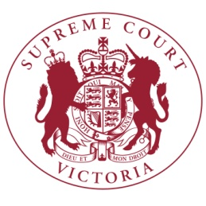

The Chief Justice has announced the **COMMERCIAL COURT** judges for 2017:

Judges –

Justice Kim Hargrave (Principal Judge)

Justice James Judd (Deputy Principal Judge)

Justice Peter Vickery

Justice Clyde Croft

Justice Michael Sifris

Justice Peter Almond

Justice John Digby

Justice James Elliott

Justice Melanie Sloss

Justice Maree Kennedy

Associate Judges -

Associate Justice Mark Derham (Principal Associate Judge)

Associate Justice John Efthim

Associate Justice Melissa Daly

Associate Justice Simon Gardiner

Associate Justice Rod Randall

Judicial Registrars –

Judicial Registrar Julian Hetyey

Judicial Registrar Patricia Matthews