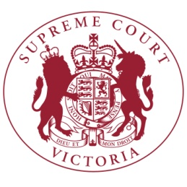

The Chief Justice has announced the **COMMON LAW** judges for 2017:

Judges –

Justice Jack Forrest (Principal Judge)

Justice Karin Emerton (Deputy Principal Judge)

Justice Tony Cavanough

Justice Kevin Bell

Justice Terry Forrest

Justice John Dixon

Justice Cameron Macaulay

Justice Kate McMillan

Justice Gregory Garde (VCAT)

Justice Timothy Ginnane

Justice Joanne Cameron

Justice Michael McDonald

Justice Rita Zammit

Justice Peter Riordan

Justice Andrew Keogh

Associate Judges -

Associate Justice Mark Derham (Principal Associate Judge)

Associate Justice Melissa Daly

Associate Justice Robyn Lansdowne

Associate Justice Mary-Jane Ierodiaconou

Judicial Registrars –

Judicial Registrar TBC