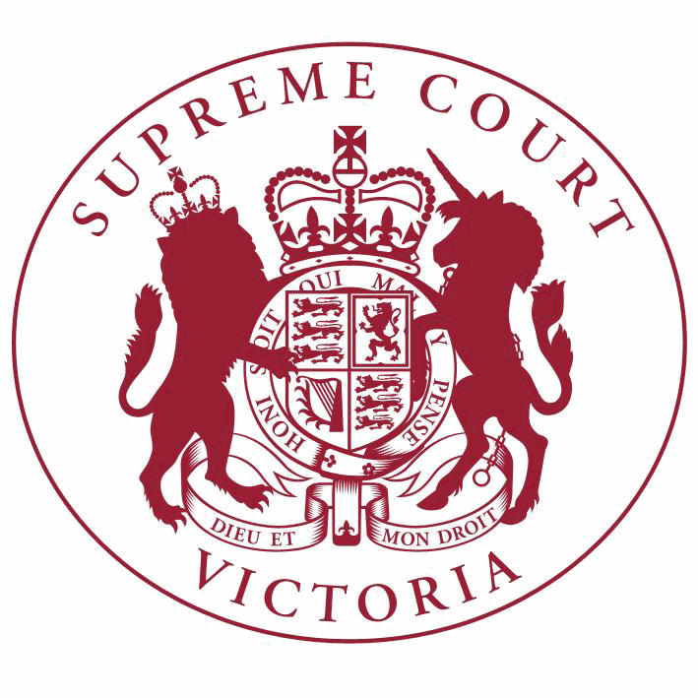

**Supreme Court List for Thursday 10 May 2018**

|  |  |
| --- | --- |
| COURT OF APPEAL  courtrooms are located at: | TRIAL DIVISION  courtrooms are located at: |
| 459 Lonsdale St. Melbourne | 210 William St. Old High Court 436 Lonsdale St. WCJC Melbourne Ground Floor Melbourne 223 William St.  450 Little Bourke St. Melbourne  Melbourne |

**NOTICES TO THE PROFESSION AND OTHER SUPREME COURT USERS**

A welcome ceremony for the Honourable Justice Richards will be held today in the Banco Court. Counsel are requested to robe.

--------------------------------------------------------

**Full Court**

**The Chief Justice, The President, Justice Richards**

Court 1, Ground Floor

210 William Street, Melb.

9:15 Welcome Ceremony

**Court of Appeal**

**Criminal Division**

**Justice Tate, Justice Beach, Justice Kyrou**

Blue Court, Second Floor

459 Lonsdale Street, Melb.

9:30 S APCR 2017 0194

Udochukwa Prince Nwachukwu

v. R

For Judgment - Leave to Appeal

9:30 S APCR 2017 0194

Udochukwa Prince Nwachukwu

v. R

Judgment

**Trial Division**

**Criminal Division**

**Justice Bell**

Court 10, Ground Floor

210 William Street, Melb.

10:30 S CR 2014 0080

R

v. Clifford John GERATHY

Application

**Criminal Division**- Continued

**Justice Lasry**

Court 4, Ground Floor

210 William Street, Melb.

**Trial Division** - Continued

10:00 S CR 2016 0177

R

v. Peter James ARTHUR

For Mention

10:00 S CR 2017 0163

R

**Justice Croucher**

Court 1, Ground Floor

210 William Street, Melb.

v. Karl Michael HAGUE

For Mention

10:30 S CR 2017 0311

R

**Justice Jane Dixon**

Court 11, Ground Floor

210 William Street, Melb.

v. Angelo Pat RUSSO

Preliminary Argument

10:30 S CR 2017 0107

R

**Justice Champion**

Court 2, Ground Floor

210 William Street, Melb.

v. L R

Part Heard

10:30 S CR 2017 0084

R

**Justice Coghlan**

Court 4, Ground Floor

210 William Street, Melb.

v. Danny Noel VOLPE

Trial

9:30

S CR 2018 0121

In the matter of an application under the Surveillance Devices Act 1999

Application under the Surveillance Devices Act

9:30

S CR 2018 0122

In the matter of an application under the Surveillance Devices Act 1999

Application under the Surveillance Devices Act

**Justice Coghlan**

Green Court, Ground Floor

459 Lonsdale Street, Melb.

10:30

S CR 2018 0092

In the matter of an application by Casey SCOTT

Application for Bail

**Common Law Division**

**Justice John Dixon**

Court 15, Ground Floor

210 William Street, Melb.

**Trial Division** - Continued

Major Torts list

10:30 S CI 2015 03382

Roo-Roofing Pty Ltd (ACN 092

931 676) & Ors.

v. The Commonwealth of Australia

Part Heard

**Justice Keogh**

Court 9, First Floor

210 William Street, Melb.

Major Torts list

10:00 S CI 2016 00811

Robert Marinelli

**Judicial Registrar Irving**

Mediation Room 3 Level 6 (436 Lonsdale St)

436 Lonsdale Street, Melb.

v. State of Victoria

Application

10:00 S CI 2017 04587

Catherine Rebecca Aedy Naismith

**Practice Court (Common Law)**

**Justice Bell**

Court 10, Ground Floor

210 William Street, Melb.

v. Mary Christina Fraser (who is sued as the executor of the Will of Brian Andrew Hazel Fraser, deceased) & Ors.

For Mediation

10.30 Practice Court Business

**URGENT APPLICATIONS** Contact the Associate to the Practice Court Judge **(AFTER HOURS ONLY)** on

0412 251 757 or 0419 303 981

During business hours, contact the Practice Court Coordinator on 9603 9288.

**Commercial Court**

**Justice Croft**

Court 1, Ground Floor

Old High Court

450 Little Bourke Street, Melb.

Arbitration List

4:30 S CI 2017 02869

QBH Commercial Enterprises Pty

Ltd (ACN 163 992 498)

v. Dalle Projects Pty Ltd (ACN 147 573

948)

Application

**Commercial Court**- Continued

4:30 S ECI 2018 00058

**Trial Division** - Continued

For Judgment

Lin Tiger Plastering Pty Ltd (ACN v.

131 565 494) **Associate Justice Efthim** Court 4, Ground Floor

436 Lonsdale Street, Melb.

Platinum Construction Vic Pty Ltd

(ACN 095 739 012)

10:30

1 S CI 2013 03307

Gee Dee Nominees Pty Ltd as trustee of the G & D Petsinis Family Trust & Ors.

v. Tower Hill One Investments Pty Ltd as trustee of the Tower Hill One Investments Unit Trust & Ors.

Application

Corporations List

10:00

2 S ECI 2017 00298

Ross Andrew Blakeley, Quentin James Older and John Richard Park (In Their Capacity as Liquidators of Laura Ashley (Australia) Pty Ltd (In Liquidation) (ACN 004 817 323)

& Ors.

v. The Commissioner of Taxation of the

Commonwealth of Australia & Ors.

Application

**Associate Justice Randall**

Court 6, Ground Floor

436 Lonsdale Street, Melb.

Corporations List

10:30

1 S ECI 2016 01251

Antony Battaglia & Ors.

v. Antonio Capuano & Ors.

Directions Hearing

2:15

2 S CI 2017 05175

Vuka Investments Pty Ltd (ACN

123 849 187)

v. Tulacon Holding Pty Ltd (ACN 159

551 765)

Directions Hearing

**Associate Justice Derham**

Court 2, Ground Floor

436 Lonsdale Street, Melb.

Taxation List

10:30

1 S CI 2017 02394

Deputy Commissioner of Taxation

v. Roberto Sergio Morando

Application

**Judicial Registrar Hetyey**

Court 3, Ground Floor

436 Lonsdale Street, Melb.

Corporations List

**Commercial Court**- Continued

10:30 S ECI 2017 00290

**Trial Division** - Continued

Initial Conference

Film Montage Pty Ltd (ACN 005

981 484)

v. Toombak Indigenous Production Pty

Ltd (ACN 128 936 416) & Ors.

10:30 S ECI 2018 00007

Julie Maree Johnston

v. Paul Owen Rodaughan & Ors.

For Mention

**Commercial Court Duty Judge**

Commercial Court Urgent Applications

**URGENT APPLICATIONS** During business hours, contact the Commercial Court Registry on 9603 4105.

Contact the Associate to the Commercial Court Duty Judge **(AFTER HOURS ONLY)** on

0439 153 522.

**Costs Court**

**Costs Registrar Conidi**

Hearing Room 1, Fourth Floor

436 Lonsdale Street, Melb.

10:00 S CI 2018 01235

David James

**Associate Judges Associate Justice Efthim** Court 4, Ground Floor

436 Lonsdale Street, Melb.

v. Seltsam Pty Ltd (ACN 000 003 734)

Costs Court Mediation

2:15

1 S CI 2014 04964

Colin Parkes & Ors.

v. Yarra Valley Water Corporation

Application

**Associate Justice Wood**

Room 2, Mediation Centre, Sixth Floor

436 Lonsdale Street, Melb.

2:15

1 S CI 2018 01594

Bairnsdale Family Medical Centre

Pty Ltd

v. Andrew Haig & Ors.

For Mediation

**Associate Justice Daly**

Court 14, First Floor

210 William Street, Melb.

10:30

1 S CI 2017 03345

Robyn Poon

v. Vicinity Custodian Pty Ltd & Ors.

Trial

**Associate Justice Daly**

Court 3, Ground Floor

436 Lonsdale Street, Melb.

**Associate Judges**- Continued

4:00

1 S CI 2016 04737

Matthew Gabelich

v. Andrew Donaghey

For Judgment

**Associate Justice Gardiner**

Court 5, Ground Floor

436 Lonsdale Street, Melb.

10:30

1 S CI 2013 03929

Ascot Vale Self Storage Centre v. Pty Ltd (Receivers and Managers Appointed)(In Liquidation) & Ors.

Nom De Plume Nominees Pty Ltd & Ors.

Application

**Associate Justice Derham**

Court 2, Ground Floor

436 Lonsdale Street, Melb.

10:30

1 S CI 2017 03267

585 Derrimut Road Pty Ltd (ACN

618 500 208)

v. Eileen Carmen Barber

Directions Hearing

10:30

2 S CI 2017 03766

Rei Collaco

v. Marcus Adroaldo Collaco (as administrator of Estate, Audrey Doreen Callaco) & Ors.

Directions Hearing

10:30

3 S CI 2018 00735

In the matter of an application by Darren Francis Goodwin & Ors.

Application for

Restrictive Covenant

10:30

4 S ECI 2018 00079

Trident Group (Aust) Pty Ltd

(ACN 159 834 134)

v. Ashwani Jain & Ors.

First Directions

**End of Listing**