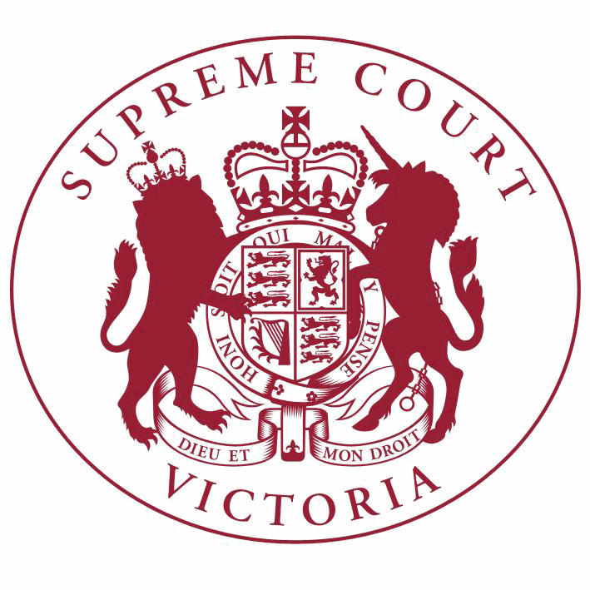

**Supreme Court List for Wednesday 30 May 2018**

|  |  |
| --- | --- |
| COURT OF APPEAL  courtrooms are located at: | TRIAL DIVISION  courtrooms are located at: |
| 459 Lonsdale St. Melbourne | 210 William St. Old High Court 436 Lonsdale St. WCJC Melbourne Ground Floor Melbourne 223 William St.  450 Little Bourke St. Melbourne  Melbourne |

**NOTICES TO THE PROFESSION AND OTHER SUPREME COURT USERS**

A welcome ceremony for the Honourable Justice Lyons will be held today in the Banco Court. Counsel are requested to robe.

--------------------------------------------------------

**Full Court**

**Acting Chief Justice, Justice Riordan, Justice Lyons**

Court 1, Ground Floor

210 William Street, Melb.

9:15 Welcome Ceremony

**Court of Appeal**

**Criminal Division**

**Justice Whelan, Justice Beach, Justice McLeish**

Green Court, Ground Floor

459 Lonsdale Street, Melb.

10:00 S APCR 2017 0159

Paul Frederick Smith

v. R

For Judgment - Leave to Appeal

10:00 S APCR 2017 0159

Paul Frederick Smith

**Civil Division**

**Judicial Registrar Irving**

Court 1, Ground Floor

436 Lonsdale Street, Melb.

v. R

Judgment

9:15 S APCI 2018 0044

Atkinson Prakash Charan

v. Nationwide News Pty Ltd (ACN 008

438 828)

Directions Hearing

**Trial Division**

**Criminal Division**

**Justice Kaye**

Court 3, Ground Floor

210 William Street, Melb.

10:30 S CR 2017 0004

R

v. Christine Ann LYONS

Part Heard

10:30 S CR 2017 0005

R

**Justice Hollingworth**

Sitting at County Court G-1

250 William Street, Melb.

v. Ronald LYONS

Part Heard

10:30 S CR 2017 0204

R

v. Alexander Dow FREEBURN

Part Heard

**Justice Bell**

Court 4, Ground Floor

210 William Street, Melb.

10:15 S CR 2014 0080

R

**Justice T Forrest**

Green Court, Ground Floor

459 Lonsdale Street, Melb.

v. Clifford John GERATHY

For Sentence

10:30

S CR 2018 0138

In the matter of an application by Bryce HALL

Application for Bail

**Justice Croucher**

Court 1, Ground Floor

210 William Street, Melb.

10:30 S CR 2017 0311

R

v. Angelo Pat RUSSO

For Plea

**Justice Beale**

Court 11, Ground Floor

210 William Street, Melb.

10:30 S CR 2016 0147

R

**Justice Jane Dixon**

Court 11, Ground Floor

210 William Street, Melb.

v. Huong DUONG

Special Hearing

9:30 S CR 2017 0114

R

v. Yu Tung LO

For Mention

**Criminal Division**- Continued

**Justice Jane Dixon**

Court 4, Ground Floor

210 William Street, Melb.

**Trial Division** - Continued

2:15

S CR 2018 0150

In the matter of an application under the Surveillance Devices Act 1999

Application under the Surveillance Devices Act

**Justice Champion**

Court 2, Ground Floor

210 William Street, Melb.

10:30 S CR 2017 0084

R

**Common Law Division**

**Justice Bell**

Court 4, Ground Floor

210 William Street, Melb.

v. Danny Noel VOLPE

Part Heard

Judicial Review and Appeals List

10:00 S CI 2017 02482

Vincent Fallon

**Justice T Forrest**

Court 5, Ground Floor

210 William Street, Melb.

v. Jessica Johnston

For Judgment

9:30 S CI 2018 01788

Jerry Glenis & Ors.

**Justice Emerton**

Court 14, First Floor

210 William Street, Melb.

v. Peter Ikosidekas & Ors.

For Judgment

Valuation Compensation and Planning List

10:30 S CI 2014 00421

Paolo Carbone & Ors.

v. Melton City Council & Ors.

Trial

10:30 S CI 2018 00804

Paolo Carbone & Ors.

**Justice John Dixon**

Court 15, Ground Floor

210 William Street, Melb.

v. Melton City Council

Trial

Major Torts list

**Common Law Division**- Continued

10:30 S CI 2015 03382

**Trial Division** - Continued

Part Heard

Roo-Roofing Pty Ltd (ACN 092

931 676) & Ors.

**Justice Macaulay**

Court 13, First Floor

210 William Street, Melb.

v. The Commonwealth of Australia

4:15 S CI 2015 05119

Advanced Fuels Technology Pty

Ltd (ACN 079 473 699)

Judicial Review and Appeals List

v. Sean Blythe & Ors.

For Judgment

3:45 S CI 2017 02468

Director of Public Prosecutions

(on behalf of Robert Baker)

**Justice Zammit**

Court 7B, Ground Floor

210 William Street, Melb.

v. Jason Tupper

For Judgment

10:30

1 S CI 2017 01375

Paul Barrett

v. Hunstman Chemical Company

Australia Pty Limited (ACN 004 146

338) & Ors.

Trial

**Justice Keogh**

Court 12, Ground Floor

210 William Street, Melb.

Major Torts list

10:30 S CI 2016 00811

Robert Marinelli

**Judicial Registrar Matthews**

Room 2, Mediation Centre, Sixth Floor

436 Lonsdale Street, Melb.

v. State of Victoria

Application

10:00 S CI 2017 01370

Steven Bowden

**Judicial Registrar Clayton**

Court 1, Ground Floor

436 Lonsdale Street, Melb.

v. Murray Valley Aboriginal Cooperative

For Mediation

10:30 S CI 2018 01682

John Richard Horne Benzie

**Practice Court (Common Law)**

**Justice Richards**

v. Amaca Pty Limited (ACN 000 035

512) (formerly James Hardie & Coy

Pty Ltd) & Ors.

Application

Court 10, Ground Floor

210 William Street, Melb.

**Trial Division** - Continued

10.30 Practice Court Business

**URGENT APPLICATIONS** Contact the Associate to the Practice Court Judge **(AFTER HOURS ONLY)** on

0412 251 757 or 0419 303 981

During business hours, contact the Practice Court Coordinator on 9603 9288.

**Commercial Court**

**Justice Sifris**

Court 1, Ground Floor

Old High Court

450 Little Bourke Street, Melb.

10:00 S ECI 2016 01212

McCrohan Super Investments Pty

Ltd (ACN 162 030 168) & Ors.

v. Maria Luisa Ashdown & Ors.

Trial

**Justice Elliott**

Court 6, Third Floor

223 William Street, Melb.

10:00 S ECI 2014 00146

Cargill Australia Limited (ACN

004 684 173) **Associate Justice Efthim** Court 6, First Floor

210 William Street, Melb.

v. Viterra Malt Pty Ltd (ACN 096 519

658) & Ors.

Application

Corporations List

10:30

1 S CI 2017 01458

Anthony Robert Cant (in their capacity as liquidators of Eliana Construction and Developing Group Pty Ltd (in liquidation) (ACN 132 817 362) & Ors.

v. Mad Brothers Earthmoving Pty Ltd

(ACN 122 889 007)

Trial

**Associate Justice Gardiner**

Court 4, Ground Floor

436 Lonsdale Street, Melb.

Corporations List

10:30

1 S CI 2017 04752

Keybridge Capital Limited (ACN

088 267 190)

v. Molopo Energy Limited (ACN 003 152

154) & Ors.

Application

**Associate Justice Randall**

Court 6, Ground Floor

436 Lonsdale Street, Melb.

**Commercial Court**- Continued

**Trial Division** - Continued

Company Applications not for Winding Up

10:30

1 S CI 2018 01705

Befficient By GSI Pty Ltd (ACN

167 272 282)

v. AGL Sales Pty Ltd (ACN 090 538

337)

10:30

2 S CI 2018 01749

Erfanian Developments Pty Ltd

(ACN 140 457 601)

v. Hydraciv Plumbing Pty Ltd (ACN 159

767 969)

Corporations List

2:15

3 S ECI 2016 01152

Conrad Dudley-Bateman

v. Murray Charles Pitman & Ors.

Directions Hearing

**Judicial Registrar Hetyey**

Court 5, Ground Floor

436 Lonsdale Street, Melb.

Company Winding Up Applications

10:30

S CI 2018 01184

In the matter of R3D Media Pty Ltd (ACN 601 117 104)

10:30

S CI 2018 01339

In the matter of Etona Pty Ltd (ACN 081 112 852)

10:30

S CI 2018 01492

In the matter of Panalpina World Tranport Pty Ltd (ACN 000 525 995)

10:30

S CI 2018 01493

In the matter of Icon Tiling & Stone Pty Ltd (ACN 152 346 373)

10:30

S CI 2018 01503

In the matter of Dojen Pty Ltd ATF DT Family Trust (ACN 114 504 004)

10:30

S CI 2018 01505

In the matter of Yellow Tractor Pty Ltd (ACN 151 340 519)

10:30

S CI 2018 01506

In the matter of Property Guide Pty Ltd (ACN 614 895 064)

10:30

S CI 2018 01520

In the matter of Reliance Franchise Partners Pty Ltd (ACN 151 750 613)

**Commercial Court**- Continued

**Trial Division** - Continued

10:30

S CI 2018 01524

In the matter of Gippsland Ocean View Restaurant Pty Ltd (ACN 607 661

978)

10:30

S CI 2018 01537

In the matter of Monte Carlo Travel Pty Ltd (ACN 111 342 931)

10:30

S CI 2018 01538

In the matter of Smartcars Australia Pty Ltd (ACN 146 104 814)

10:30

S CI 2018 01553

In the matter of Amana Family Day Care Pty Ltd ACN 159 894 005

10:30

S CI 2018 01609

In the matter of Tritech Investments Holdings Pty Ltd (ACN 097 321 125)

10:30

S CI 2018 01615

In the matter of Welcome Supermarket Supplies Pty Ltd (ACN 607 293 925)

10:30

S CI 2018 01616

In the matter of Erciyes Pty Ltd (ACN 612 484 410)

10:30

In Chambers

S CI 2018 01620

In the matter of Jarit (Aust) Pty Limited (ACN 000 514 394)

Corporations List

2:30 S ECI 2017 00256

Graeme Philip Langford

Thompson

**Commercial Court Duty Judge**

Commercial Court Urgent Applications

v. Elizabeth Ann Buxton & Ors.

By Telephone

Conference

**URGENT APPLICATIONS** During business hours, contact the Commercial Court Registry on 9603 4105.

Contact the Associate to the Commercial Court Duty Judge **(AFTER HOURS ONLY)** on

0439 153 522.

**Costs Court**

**Judicial Registrar Gourlay**

Court 7, Fourth Floor

436 Lonsdale St, Melb.

**Costs Court**- Continued

10:00 S CI 2018 00579

Hope St Student Accommodation

Pty Ltd (ACN 140 804 780)

**Costs Registrar Conidi**

Hearing Room 1, Fourth Floor

436 Lonsdale Street, Melb.

v. J.J Armstrong Pty Ltd (ACN 075 084

687)

Taxation of Costs

10:00 S CI 2018 01635

Mark Anthony Korda (as joint and several liquidator of Legen International Holdings Inc. (In Liquidation) ARBN 120 855 352)

& Ors. **Costs Registrar Conidi** Hearing Room 2, Fourth Floor

436 Lonsdale Street, Melb.

v. Queensland Phosphate Pty Ltd (ACN

609 384 894) & Ors.

Costs Court Mediation

2:00 S CI 2018 01737

Evelyn Joyce Barwis

**Associate Judges**

**Associate Justice Wood**

Mediation Room 3 Level 6 (436 Lonsdale St)

436 Lonsdale Street, Melb.

v. Scotts Agencies Property Limited & Ors.

Costs Court Mediation

10:00

1 S CI 2017 04392

Fauna And Flora Research

Collective Inc

v. Secretary to the Department of Environment, Land, Water and Planning & Ors.

For Mediation

**Associate Justice Lansdowne**

Court 2, Ground Floor

436 Lonsdale Street, Melb.

10:30

1 S CI 2018 00345

Cyprian John O'Neill

v. Professor Alexander Holmes and Dr Brendan Hayman (Medical Panel) & Ors.

Application

**Associate Justice Daly**

Court 4, Ground Floor

436 Lonsdale Street, Melb.

10:30

1 S CI 2015 04680

Silvana Taseska

v. Henry Joseph Carus & Ors.

Application

4:15

2 S CI 2017 02461

Ronald Ptasznik

v. Australian Medical Association

(Victoria) Limited (ACN 064 447 678)

& Ors.

For Judgment

4:15

3 S CI 2017 02462

Stephen Stuckey

v. Australian Medical Association

(Victoria) Limited (ACN 064 447 678)

& Ors.

For Judgment

**Pre-Trial Conferences Deputy Prothonotary Price** Conference Room, Fourth Floor

436 Lonsdale Street, Melb.

10:00 S CI 2018 00074

Donald Fry

**Deputy Prothonotary Valladares**

Conference Room, Fourth Floor

436 Lonsdale Street, Melb.

v. Clements Langford Proprietary

Limited (ACN 004 101 580) & Ors.

Pre-Trial Conference

2:00 S CI 2018 00725

Nicholas Scott Blake

**End of Listing**

v. Comcare

Pre-Trial Conference