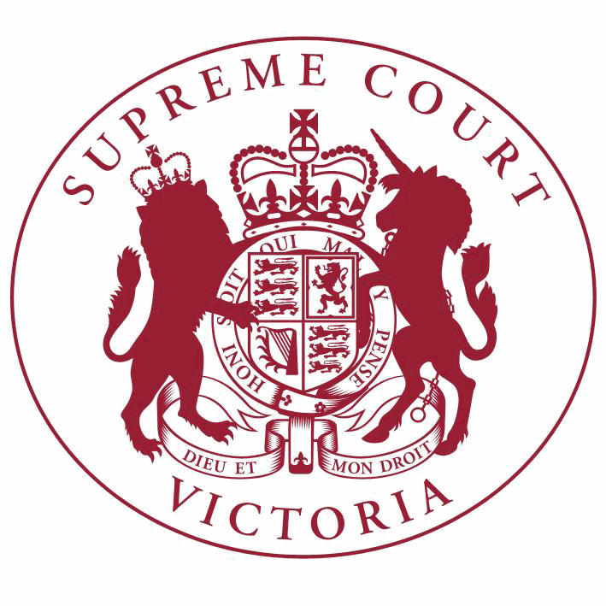

**Supreme Court List for Tuesday 29 May 2018**

|  |  |
| --- | --- |
| COURT OF APPEAL  courtrooms are located at: | TRIAL DIVISION  courtrooms are located at: |
| 459 Lonsdale St. Melbourne | 210 William St. Old High Court 436 Lonsdale St. WCJC Melbourne Ground Floor Melbourne 223 William St.  450 Little Bourke St. Melbourne  Melbourne |

**Court of Appeal**

**Criminal Division**

**Acting Chief Justice, Justice Priest, Justice Kyrou**

Green Court, Ground Floor

459 Lonsdale Street, Melb.

10:30 S APCR 2017 0127

Dimi Sovolos

v. R

Application for Leave to

Appeal (oral hearing)

10:30 S APCR 2017 0127

Dimi Sovolos

**Civil Division**

**Justice Beach, Justice McLeish, Justice Niall**

Red Court, First Floor

459 Lonsdale Street, Melb.

v. R

Hearing

10:30 S APCI 2017 0107

Robert Stanojlovic

v. Director of Public of Prosecutions (on behalf of Steven Emil Kokas) & Ors.

Application for Leave to

Appeal (oral hearing)

10:30 S APCI 2017 0107

Robert Stanojlovic

v. Director of Public of Prosecutions (on behalf of Steven Emil Kokas) & Ors.

For Hearing of Appeal

**Trial Division**

**Criminal Division**

**Justice Kaye**

Court 3, Ground Floor

210 William Street, Melb.

10:30 S CR 2017 0004

R

v. Christine Ann LYONS

Part Heard

**Criminal Division**- Continued

10:30 S CR 2017 0005

**Trial Division** - Continued

Part Heard

R

**Justice Hollingworth**

Sitting at County Court G-1

250 William Street, Melb.

v. Ronald LYONS

10:30 S CR 2017 0204

R

v. Alexander Dow FREEBURN

Part Heard

**Justice Bell**

Court 4, Ground Floor

210 William Street, Melb.

10:30

**Justice Lasry**

S CR 2018 0128

In the matter of an application by Zakary Michael NORTON

Application for Bail

Court 4, Ground Floor

210 William Street, Melb.

9:30 S CR 2018 0148

R

v. Albert TEDFORD

Post Committal

Directions

**Justice Beale**

Court 11, Ground Floor

210 William Street, Melb.

2:15 S CR 2016 0147

R

**Justice Champion**

Court 2, Ground Floor

210 William Street, Melb.

v. Huong DUONG

Special Hearing

10:30 S CR 2017 0084

R

**Common Law Division**

**Justice T Forrest**

Court 5, Ground Floor

210 William Street, Melb.

v. Danny Noel VOLPE

Part Heard

10:30 S CI 2015 02078

Peter Paul Belmuda

**Justice Jane Dixon**

Court 1, Ground Floor

210 William Street, Melb.

v. The Grand International Entertainment

Centre Pty Ltd (ACN 076 606 474)

Trial

**Common Law Division**- Continued

**Trial Division** - Continued

10:30

**Justice Keogh**

S CI 2015 01532

In the matter of the Crimes (Mental Impairment and Unfitness to be Tried) Act 1997: K K

Application under the Crimes (MIUT) Act (s57)

Court 12, Ground Floor

210 William Street, Melb.

Judicial Review and Appeals List

10:30 S CI 2016 04496

Viswanathan Murugesu (by his litigation guardian Kovarthini Murugesu)

**Judicial Registrar Englefield**

Room 1, Mediation Centre, Sixth Floor

436 Lonsdale Street, Melb.

v. Ruban Pty Ltd & Ors.

For Ruling

10:00 S CI 2017 05230

Susan Joy Hartigan & Ors.

**Judicial Registrar Matthews**

Court 5, Ground Floor

436 Lonsdale Street, Melb.

v. Christine Margaret Hawkins (Who is sued as the Executor of the Will of Margaret Elizabeth Smeeton, Deceased)

For Mediation

2:30 S CI 2018 00128

Leithead Pty Ltd (ACN 154 703

232) & Ors.

**Practice Court (Common Law)**

**Justice Richards**

Court 10, Ground Floor

210 William Street, Melb.

v. Nikos Nikolaou & Ors.

Directions Hearing

10.30 Practice Court Business

**URGENT APPLICATIONS** Contact the Associate to the Practice Court Judge **(AFTER HOURS ONLY)** on

0412 251 757 or 0419 303 981

During business hours, contact the Practice Court Coordinator on 9603 9288.

**Commercial Court**

**Justice Croft**

Court 2, Ground Floor

Old High Court

450 Little Bourke Street, Melb.

**Commercial Court**- Continued

10:00 S CI 2017 01066

**Trial Division** - Continued

Trial

**Justice Sifris**

Fitzpatrick Investments Pty Ltd

(ACN 001 662 862)

v. CSC Australia Pty Ltd (ACN 008 476

944)

Court 1, Ground Floor

Old High Court

450 Little Bourke Street, Melb.

10:00 S ECI 2016 01212

McCrohan Super Investments Pty

Ltd (ACN 162 030 168) & Ors.

**Justice Riordan** Court 3, Ground Floor Old High Court

450 Little Bourke Street, Melb.

v. Maria Luisa Ashdown & Ors.

Trial

10:30 S CI 2016 00299

Glenn Ashley Cullen & Ors.

**Associate Justice Efthim**

Court 6, First Floor

210 William Street, Melb.

v. Warren Dennis Cullen & Ors.

Trial

Corporations List

10:30

1 S CI 2017 01458

Anthony Robert Cant (in their capacity as liquidators of Eliana Construction and Developing Group Pty Ltd (in liquidation) (ACN 132 817 362) & Ors.

v. Mad Brothers Earthmoving Pty Ltd

(ACN 122 889 007)

Trial

**Associate Justice Wood**

Mediation Room 3 Level 6 (436 Lonsdale St)

436 Lonsdale Street, Melb.

Corporations List

10:00

1 S ECI 2018 00110

BLK Management Pty Ltd (ACN

134 575 947) & Ors.

v. Robert Frandsen & Ors.

For Mediation

**Judicial Registrar Matthews**

Court 5, Ground Floor

436 Lonsdale Street, Melb.

10:00 S CI 2016 04216

Souhail Mondous & Ors.

v. Sebastian Canzoneri & Ors.

Application

**Trial Division** - Continued

**Commercial Court Duty Judge**

Commercial Court Urgent Applications

**URGENT APPLICATIONS** During business hours, contact the Commercial Court Registry on 9603 4105.

Contact the Associate to the Commercial Court Duty Judge **(AFTER HOURS ONLY)** on

0439 153 522.

**Costs Court**

**Costs Registrar Conidi**

Hearing Room 2, Fourth Floor

436 Lonsdale Street, Melb.

10:00 S CI 2018 00429

Jody Birch

**Associate Judges Associate Justice Mukhtar** Court 2, Ground Floor

436 Lonsdale Street, Melb.

v. Amaca Pty Ltd (Under NSW Administered Winding Up)

Taxation of Costs

10:30

1 S CI 2017 00487

Garifalia Athanasiou (by her

Administrator, State Trustees Ltd)

v. John Athanasiou & Ors.

Directions Hearing

10:30

2 S CI 2017 03207

Internet Marketing Solutions Corp

v. Environment Protection Authority

Victoria

Application

10:30

3 S CI 2018 00905

In the matter of an application by Toto Tex Pty Ltd (ACN 138 916 864)

Application for

Restrictive Covenant

10:30

4 S CI 2018 01582

Simon John Percival Hirth (in his capacity as Administrator of the estate of Ruth Pauncefaute Hillier, deceased)

v. Katherine Ann Hirth

Directions Hearing

**Associate Justice Derham**

Court 3, Ground Floor

436 Lonsdale Street, Melb.

10:30

1 S CI 2017 01796

Kate Johnson

v. Abottsford Estates Pty Ltd (ACN 614

886 958) as Trustee of the Stathelie

Holdings Trust & Ors.

Directions Hearing

10:30

2 S CI 2018 00715

Westpac Banking Corporation

(ABN 33 007 457 141)

v. Anthony Margheriti & Ors.

Application

**Associate Judges**- Continued

10:30

3 S CI 2018 01118

Luke Thomas Bower

v. PMB Management Pty Ltd (ACN 154

401 644) & Ors.

Directions Hearing

10:30

4 S CI 2018 01539

Vivien Mun Ching Chien Chu also v. known as Vivien Chien or Vivien

Mun Ching Chien

Glann Chien & Ors.

Directions Hearing

**Pre-Trial Conferences Deputy Prothonotary Munro** Conference Room, Fourth Floor

436 Lonsdale Street, Melb.

2:00 S CI 2018 00590

Philip Leslie Jackson

**End of Listing**

v. ACN 004 082 777 Pty Ltd & Ors.

Pre-Trial Conference