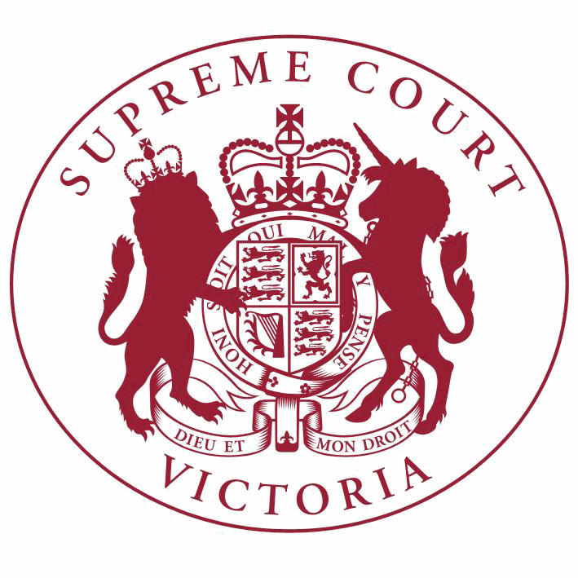

**Supreme Court List for Thursday 3 May 2018**

|  |  |
| --- | --- |
| COURT OF APPEAL  courtrooms are located at: | TRIAL DIVISION  courtrooms are located at: |
| 459 Lonsdale St. Melbourne | 210 William St. Old High Court 436 Lonsdale St. WCJC Melbourne Ground Floor Melbourne 223 William St.  450 Little Bourke St. Melbourne  Melbourne |

**Court of Appeal**

**Criminal Division**

**Justice Priest**

Blue Court, Second Floor

459 Lonsdale Street, Melb.

10:30 S APCR 2017 0260

Akin Saricayir

**Justice Tate, Justice Beach, Justice Kyrou**

Green Court, Ground Floor

459 Lonsdale Street, Melb.

v. R

Application for Bail

10:30 S APCR 2017 0194

Udochukwa Prince Nwachukwu

v. R

Application for Leave to

Appeal (oral hearing)

10:30 S APCR 2017 0194

Udochukwa Prince Nwachukwu

v. R

Hearing

**Civil Division**

**The Chief Justice, Justice Whelan, Justice McLeish**

Red Court, First Floor

459 Lonsdale Street, Melb.

10:30 S APCI 2017 0125

SLEA Pty Ltd (ACN 106 752

434) & Ors.

v. Connective Services Pty Ltd (ACN

107 366 496) & Ors.

Application for Leave to

Appeal (oral hearing)

10:30 S APCI 2017 0125

SLEA Pty Ltd (ACN 106 752

434) & Ors.

v. Connective Services Pty Ltd (ACN

107 366 496) & Ors.

For Hearing of Appeal

**Trial Division**

**Criminal Division**

**Justice Kaye**

Court 3, Ground Floor

210 William Street, Melb.

10:00 S CR 2017 0188

R

v. Dwayne Justin LINDSEY

For Plea

**Justice Bell**

Court 3, Ground Floor

210 William Street, Melb.

9:15 S CR 2014 0080

R

**Justice Jane Dixon**

Court 11, Ground Floor

210 William Street, Melb.

v. Clifford John GERATHY

Final Directions

10:30 S CR 2015 0120

R

**Justice Champion**

Court 4, Ground Floor

210 William Street, Melb.

v. Georgia FIELDS

Review under the

Crimes (MIUT) Act

1997

9:30 S CR 2017 0266

R

v. Mairown SAHHITANANDAN

Final Directions

9:30 S CR 2017 0267

R

v. Iruthayathasab Coonghe

AMALAUTPAVAM

Final Directions

2:15

S CR 2018 0106

In the matter of an application by H S

For Judgment

**Justice Coghlan**

Court 2, Ground Floor

210 William Street, Melb.

9:30

S CR 2018 0101

In the matter of an application by B W

For Judgment

10:30 S CR 2018 0024

R

**Common Law Division**

**Justice T Forrest**

Court 6, First Floor

210 William Street, Melb.

v. Craig Hunter MARSHALL

For Sentence

Major Torts list

**Common Law Division**- Continued

11:30 S CI 2016 01170

**Trial Division** - Continued

Trial

Peter Nicholas Yunghanns

**Justice John Dixon**

Court 15, Ground Floor

210 William Street, Melb.

v. Nicholas Colquhoun-Denvers

Major Torts list

10:30 S CI 2015 03382

Roo-Roofing Pty Ltd (ACN 092

931 676) & Ors.

**Justice Ginnane** Court 3, Ground Floor Old High Court

450 Little Bourke Street, Melb.

v. The Commonwealth of Australia

Part Heard

Judicial Review and Appeals List

10:30 S CI 2017 02949

Paul Mellersh Monteith

**Justice Champion**

Court 7B, Ground Floor

210 William Street, Melb.

v. Gaylor Estelle Fitzgerald & Ors.

Trial

Valuation Compensation and Planning List

10:30 S CI 2017 03195

Arshad Ali Khan

**Judicial Registrar Englefield**

Mediation Room 3 Level 6 (436 Lonsdale St)

436 Lonsdale Street, Melb.

v. VCAT Dalia Cook-Member

Trial

10:00 S CI 2017 05037

Maria Teresita Leffler

**Practice Court (Common Law)**

**Justice Bell**

Court 10, Ground Floor

210 William Street, Melb.

v. State Trustees Limited (ACN 064 593

148) (who are sued as the Administrator of the Estate of Marieta Ayudante Dawson, deceased)

For Mediation

10:30 S CI 2018 01594

Bairnsdale Family Medical Centre

Pty Ltd

v. Andrew Haig & Ors.

Application

**Trial Division** - Continued

**URGENT APPLICATIONS** Contact the Associate to the Practice Court Judge **(AFTER HOURS ONLY)** on

0412 251 757 or 0419 303 981

During business hours, contact the Practice Court Coordinator on 9603 9288.

**Commercial Court**

**Justice Croft**

Court 15, Ground Floor

210 William Street, Melb.

10:00 S ECI 2017 00030

Point Cook Community Entertainment Facility Pty Ltd (ACN 123 118 187)

v. Geelong Football Club Ltd (ACN 005

150 818)

Application

**Justice Elliott**

Court 9, First Floor

210 William Street, Melb.

10:00 S CI 2017 00237

Herbert Smith Freehills (a firm) (ABN 98 773 882 646)

v. United Petroleum Australia Pty Ltd

(ACN 164 398 832) & Ors.

Trial

10:00 S ECI 2017 00202

United Petroleum Australia Pty

Ltd (ACN 164 398 832) & Ors.

v. Herbert Smith Freehills (A Firm) (ABN 98 773 882 646) & Ors.

Trial

**Justice Robson**

Court 2, Ground Floor

Old High Court

450 Little Bourke Street, Melb.

Corporations List

10:00

S ECI 2018 00094

In the matter of an application by Mount Edisar Pty Ltd (In Liquidation) (ACN 005 758 501) & Ors.

Application

**Associate Justice Efthim**

Court 3, Ground Floor

436 Lonsdale Street, Melb.

Company Applications not for Winding Up

10:30

1 S CI 2018 00052

Eynesbury Homestead and Golf

Pty Ltd (ACN 197 791 657)

v. McMahons Pty Ltd (ACN 077 932

944)

**Associate Justice Gardiner**

Court 6, Ground Floor

436 Lonsdale Street, Melb.

Corporations List

**Commercial Court**- Continued

**Trial Division** - Continued

10:30

1 S ECI 2017 00184

Oenfao Dental Supply Pty Ltd

(ACN 604 556 103) & Ors.

v. S D Holding Group Pty Ltd (ACN 143

145 368) & Ors.

Directions Hearing

10:30

2 S ECI 2017 00256

Graeme Philip Langford

Thompson

v. Elizabeth Ann Buxton & Ors.

Directions Hearing

10:30

3 S ECI 2018 00060

Heidar Kasravi

v. Reza Kazemilar

Initial Conference

**Associate Justice Randall**

Court 5, Ground Floor

436 Lonsdale Street, Melb.

Company Applications not for Winding Up

10:30

1 S CI 2017 03895

Waterdragon Projects Pty Ltd

(ACN 102 612 939)

v. Deputy Commissioner of Taxation

**Judicial Registrar Hetyey**

Room 1, Mediation Centre, Sixth Floor

436 Lonsdale Street, Melb.

Corporations List

10:00 S ECI 2017 00286

Kavanagh Pty Ltd (ACN 064 446

466)

**Commercial Court Duty Judge**

Commercial Court Urgent Applications

v. Gerard Francis Farrell & Ors.

For Mediation

**URGENT APPLICATIONS** During business hours, contact the Commercial Court Registry on 9603 4105.

Contact the Associate to the Commercial Court Duty Judge **(AFTER HOURS ONLY)** on

0439 153 522.

**Costs Court**

**Costs Registrar Conidi**

Hearing Room 1, Fourth Floor

436 Lonsdale Street, Melb.

10:00 S CI 2018 01112

Nurisvan Investments Ltd & Ors.

v. Anyoption Holdings Ltd

Costs Court Mediation

2:00 S CI 2018 01224

Maarten Zwiersen

v. Field & Hall Pty Limited & Ors.

Costs Court Mediation

**Associate Judges Associate Justice Daly** Court 14, First Floor

210 William Street, Melb.

9:30

1 S CI 2015 04680

Silvana Taseska

v. Henry Joseph Carus & Ors.

For Mention

10:30

2 S CI 2017 03260

Kristine Mercuri

v. TCM Building Group Pty Limited

(ACN 139 290 618)

Trial

**Associate Justice Daly**

Court 2, Ground Floor

436 Lonsdale Street, Melb.

4:15

1 S CI 2016 03657

Trent Fraser

v. Business News Group Pty Ltd (ACN

606 324 403)

For Judgment

**Associate Justice Derham**

Court 2, Ground Floor

436 Lonsdale Street, Melb.

10:30

1 S CI 2016 02044

Bodycorp Repairers Pty Ltd

(ACN 068 589 408)

v. Anuniziato Enzo Maisno (also known as Michael Maisano and Michael Mason) & Ors.

Directions Hearing

10:30

2 S CI 2017 01985

Anna Maria Pandolfo (in her capacity as Administratix of the Estate of Adrian Paul Fiore Finadri)

v. Walter Finadri & Ors.

For Judgment

10:30

3 S CI 2018 00675

Bendigo and Adelaide Bank

Limited (ACN 068 049 178)

v. The Estate of Stephen Frank McLean, deceased

Application

10:30

4 S CI 2018 01291

Aviel Geron

v. Chaim Geron & Ors.

Directions Hearing

**End of Listing**