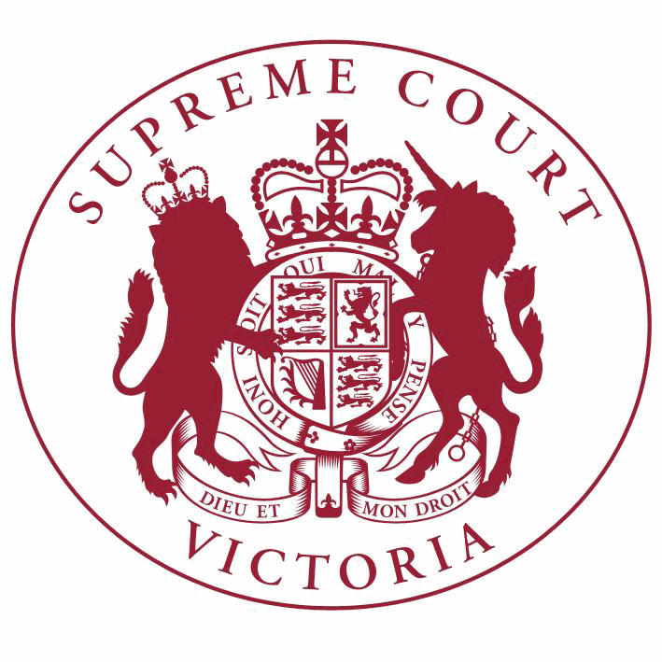

**Supreme Court List for Tuesday 12 June 2018**

|  |  |
| --- | --- |
| COURT OF APPEAL  courtrooms are located at: | TRIAL DIVISION  courtrooms are located at: |
| 459 Lonsdale St. Melbourne | 210 William St. Old High Court 436 Lonsdale St. WCJC Melbourne Ground Floor Melbourne 223 William St.  450 Little Bourke St. Melbourne  Melbourne |

**Court of Appeal**

**Criminal Division**

**Justice Whelan, Justice McLeish**

Green Court, Ground Floor

459 Lonsdale Street, Melb.

9:30 S APCR 2018 0034

Lucille Gillespie (a pseudonym)

v. R

Judgment

9:30 S APCR 2018 0034

Lucille Gillespie (a pseudonym)

**Justice Priest, Justice Beach, Justice Ashley**

Blue Court, Second Floor

459 Lonsdale Street, Melb.

v. R

For Judgment - Leave to Appeal

4:00 S APCR 2018 0005

DPP

**Civil Division**

**Justice Beach, Justice McLeish, Justice Niall**

Red Court, First Floor

459 Lonsdale Street, Melb.

v. Dylan Hutchison (a pseudonym)

Hearing

9:45 S APCI 2017 0107

Robert Stanojlovic

v. Director of Public of Prosecutions (on behalf of Steven Emil Kokas) & Ors.

For Judgment - Leave to Appeal

9:45 S APCI 2017 0107

Robert Stanojlovic

**Justice Osborn, Justice Beach**

Red Court, First Floor

459 Lonsdale Street, Melb.

v. Director of Public of Prosecutions (on behalf of Steven Emil Kokas) & Ors.

Judgment

10:00 S APCI 2018 0065

Russell Kruckman

v. Rosemary Jean Butler & Ors.

Application for Leave to

Appeal (oral hearing)

**Court of Appeal** - Continued

10:00 S APCI 2018 0065

Russell Kruckman

v. Rosemary Jean Butler & Ors.

For Hearing of Appeal

**Trial Division**

**Criminal Division**

**Justice Kaye**

Court 3, Ground Floor

210 William Street, Melb.

10:30 S CR 2017 0004

R

v. Christine Ann LYONS

Part Heard

10:30 S CR 2017 0005

R

**Justice Hollingworth**

Sitting at County Court G-1

250 William Street, Melb.

v. Ronald LYONS

Part Heard

10:30 S CR 2017 0204

R

v. Alexander Dow FREEBURN

Part Heard

**Justice Bell**

Court 1, Ground Floor

210 William Street, Melb.

10:15 S CR 2015 0170

R

v. Rocco NATALE

Special Hearing

**Justice Lasry**

Court 4, Ground Floor

210 William Street, Melb.

10:30 S CR 2017 0326

R

v. James GARGASOULAS

Special Hearing

10:30 S CR 2018 0040

R

v. James GARGASOULAS

Special Hearing

10:30 S CR 2018 0041

R

v. James GARGASOULAS

Special Hearing

10:30 S CR 2018 0042

R

v. James GARGASOULAS

Special Hearing

10:30 S CR 2018 0043

R

v. James GARGASOULAS

Special Hearing

**Criminal Division**- Continued

**Trial Division** - Continued

10:30 S CR 2018 0044

R

**Justice T Forrest**

Green Court, Ground Floor

459 Lonsdale Street, Melb.

v. James GARGASOULAS

Special Hearing

10:30 S CR 2014 0149

R

v. Adrian Roland FRANCOIS

Breach of Community

Corrections Order

2:15 S CR 2015 0049

R

**Justice Croucher**

Court 1, Ground Floor

210 William Street, Melb.

v. Lisa Jane McLAUGHLIN

Breach of Community

Corrections Order

9:30

**Justice Beale**

S CR 2015 0024

In the matter of application by Rebecca Anne LAMBERT

Directions Hearing

Court 11, Ground Floor

210 William Street, Melb.

10:30 S CR 2016 0147

R

**Justice Jane Dixon**

Court 4, Ground Floor

210 William Street, Melb.

v. H D

Special Hearing

9:30 S CR 2017 0318

R

**Justice Champion**

Court 2, Ground Floor

210 William Street, Melb.

v. Scott Alan MURDOCH

For Mention

9:00

S CR 2018 0156

In the matter of an application under the Surveillance Devices Act 1999

Application under the Surveillance Devices Act

10:30 S CR 2017 0084

R

**Common Law Division**

**Justice John Dixon**

Court 15, Ground Floor

210 William Street, Melb.

v. Danny Noel VOLPE

Part Heard

Major Torts list

**Trial Division** - Continued

10:30 S CI 2015 03382

Roo-Roofing Pty Ltd (ACN 092

931 676) & Ors.

**Justice Cameron**

Court 6, First Floor

210 William Street, Melb.

v. The Commonwealth of Australia

Part Heard

10:15 S CI 2016 00618

Garry Maxwell Baum & Ors.

v. Barports Pty Ltd (ACN 169 464 313)

Directions Hearing

**Justice Keogh**

Court 8, Ground Floor

210 William Street, Melb.

Major Torts list

10:00 S CI 2016 00811

Robert Marinelli

**Judicial Registrar Englefield**

Mediation Room 3 Level 6 (436 Lonsdale St)

436 Lonsdale Street, Melb.

v. State of Victoria

Trial

10:00 S CI 2016 01592

Stavros Pescos (also known as

Steven Pescos) **Judicial Registrar Matthews** Court 2, Ground Floor

436 Lonsdale Street, Melb.

v. Eftihia Pescos & Ors.

For Mediation

10:30 S CI 2017 00756

Craig Stephen Harris & Ors.

v. Raymond John Harris

Directions Hearing

10:30 S CI 2017 05003

Xia Lu

v. Golden Age St Kilda Development Pty

Ltd (ACN 168 667 374)

Directions Hearing

10:30 S CI 2017 05012

Frances Mary McDowall, Paul John McDowall and Peter Francis McDowall (as executors for the estate of John McDowall, deceased) & Ors.

**Practice Court (Common Law)**

**Justice Garde**

Court 10, Ground Floor

210 William Street, Melb.

v. Lattice Energy Limited (ACN 007 845

338) & Ors.

Directions Hearing

10:30 S CI 2018 02167

**Trial Division** - Continued

Application

Corley Moor (Narre Warren) Pty

Ltd (ACN 605 507 453)

v. Edindeen Pty Ltd (ACN 005 810 793)

& Ors.

**URGENT APPLICATIONS** Contact the Associate to the Practice Court Judge **(AFTER HOURS ONLY)** on

0412 251 757 or 0419 303 981

During business hours, contact the Practice Court Coordinator on 9603 9288.

**Commercial Court**

**Justice Croft**

Court 13, First Floor

210 William Street, Melb.

Corporations List

4:30 S ECI 2016 01260

MIS Funding No. 1 Pty Limited

(ACN 119 268 905)

v. Hasan Basri Hazra

Application

**Justice Elliott**

Court 6, Third Floor

223 William Street, Melb.

10:00 S ECI 2014 00146

Cargill Australia Limited (ACN

004 684 173)

**Justice Riordan** Court 3, Ground Floor Old High Court

450 Little Bourke Street, Melb.

v. Viterra Malt Pty Ltd (ACN 096 519

658) & Ors.

Application

10:00 S ECI 2018 00070

TSSI Mawson Lakes Pty Ltd

(ACN 134 678 354)

Corporations List

v. Unicorn Crystal Holdings Pty Ltd

(ACN 073 079 455) & Ors.

For Mention

10:30

**Justice Lyons**

S CI 2014 04719

In the Matter of Austwide Corporation Pty Ltd (ACN 008 441 067)

Application

Court 12, Ground Floor

210 William Street, Melb.

10:00 S CI 2016 04216

Souhail Mondous & Ors.

**Associate Justice Wood**

Mediation Room 3 Level 6 (436 Lonsdale St)

436 Lonsdale Street, Melb.

v. Sebastian Canzoneri & Ors.

Trial

Corporations List

**Commercial Court**- Continued

**Trial Division** - Continued

10:00

1 S ECI 2017 00290

Film Montage Pty Ltd (ACN 005

981 484)

v. Toombak Indigenous Production Pty

Ltd (ACN 128 936 416) & Ors.

For Mediation

**Associate Justice Gardiner**

Court 5, Ground Floor

436 Lonsdale Street, Melb.

Company Applications not for Winding Up

10:30

1 S CI 2018 00783

In the Matter of Sceam Construction Pty Ltd (ACN 141 136 816)

**Judicial Registrar Matthews**

Court 2, Ground Floor

436 Lonsdale Street, Melb.

10:30 S CI 2016 01053

Eng Hock Yap

v. Yew Han Lee & Ors.

Directions Hearing

10:30 S CI 2017 04544

Francesco Martini as Trustee for the Francesco Martin Trust

v. FSD Construction Pty Ltd (ACN 137

609 619) as Trustee for the F S Martini

Family Trust & Ors.

Application to Join

Party/s

10:30 S CI 2018 00147

Victor Leslie Cumner

v. John Bird & Ors.

Directions Hearing

10:30 S CI 2018 00147

Victor Leslie Cumner

v. John Bird & Ors.

Application

**Commercial Court Duty Judge**

Commercial Court Urgent Applications

**URGENT APPLICATIONS** During business hours, contact the Commercial Court Registry on 9603 4105.

Contact the Associate to the Commercial Court Duty Judge **(AFTER HOURS ONLY)** on

0439 153 522.

**Costs Court**

**Costs Registrar Walton**

Hearing Room 1, Fourth Floor

436 Lonsdale Street, Melb.

10:00 S CI 2018 01027

David Jeffrey & Ors.

**Associate Judges**

v. Virginia Giles

Taxation of Costs

**Associate Justice Efthim**

Room 2, Mediation Centre, Sixth Floor

436 Lonsdale Street, Melb.

10:00

1 S CI 2017 00891

Michela Joy Burke

v. Ash Sounds Pty Ltd trading as The

Falls Music and Arts Festival (ABN 67

160 019 152)

For Mediation

**Associate Justice Derham**

Court 3, Ground Floor

436 Lonsdale Street, Melb.

10:30

1 S CI 2014 01615

Meena Kumari Sharma (in her v. capacity as Administrator

appointed ad litem to represent the

Estate of Ishwar Dass, deceased)

Kirpa Ram (also known as Kirpa Ram

Sharma)

Directions Hearing

10:30

2 S CI 2014 05030

Kirpa Ram Sharma

v. Meena Kumari Sharma

Directions Hearing

10:30

3 S CI 2016 04776

Kameel Mondous

v. Alessandro Pierfrancesco Morandini

& Ors.

Directions Hearing

10:30

4 S CI 2017 05137

Carmen Stellini

v. Zhaoqing Dai & Ors.

For Mention

10:30

5 S CI 2017 05177

Zhaoqing Dai

v. Robert Liu & Ors.

For Mention

10:30

6 S CI 2018 00675

Bendigo and Adelaide Bank

Limited (ACN 068 049 178)

v. The Estate of Stephen Frank McLean, deceased

Application

10:30

7 S CI 2018 01452

Clifford Wayne Sanford

v. Leanne Marie Tymms (also known as Leanne Marie Westhead and Leanne Marie Vassallo) & Ors.

Directions Hearing

**Associate Justice Ierodiaconou**

Court 1, Ground Floor

436 Lonsdale Street, Melb.

10:30

1 S CI 2016 03662

Lucy Cathleen Carley

v. Helena Lutar (who is sued in her capacity as the Executrix of the Will and the Trustee of the Estate of LINA CHOJNACKI deceased

Trial

**Pre-Trial Conferences Deputy Prothonotary Clark** Conference Room, Fourth Floor

436 Lonsdale Street, Melb.