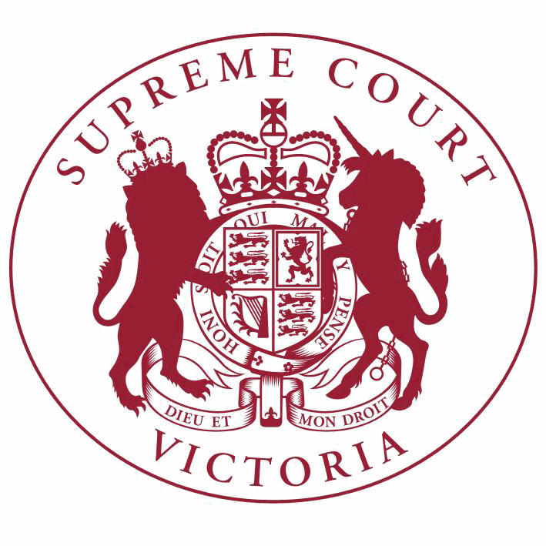

**Supreme Court List for Wednesday 13 June 2018**

|  |  |
| --- | --- |
| COURT OF APPEAL  courtrooms are located at: | TRIAL DIVISION  courtrooms are located at: |
| 459 Lonsdale St. Melbourne | 210 William St. Old High Court 436 Lonsdale St. WCJC Melbourne Ground Floor Melbourne 223 William St.  450 Little Bourke St. Melbourne  Melbourne |

**Court of Appeal**

**Criminal Division**

**The Acting Chief Justice, Justice Priest, Justice Beach**

Green Court, Ground Floor

459 Lonsdale Street, Melb.

10:30 S APCR 2017 0128

Brett Audsley

v. R

Application for Leave to

Appeal (oral hearing)

10:30 S APCR 2017 0128

Brett Audsley

**Civil Division**

**Judicial Registrar Irving**

Court 1, Ground Floor

436 Lonsdale Street, Melb.

v. R

Hearing

9:45 S APCI 2018 0047

Bodycorp Repairers Pty Ltd

(ACN 068 589 408)

v. Anuniziato Enzo Maisno (also known as Michael Maisano and Michael Mason) & Ors.

Directions Hearing

**Trial Division**

**Criminal Division**

**Justice Kaye**

Court 3, Ground Floor

210 William Street, Melb.

10:30 S CR 2017 0004

R

v. Christine Ann LYONS

Part Heard

10:30 S CR 2017 0005

R

v. Ronald LYONS

Part Heard

**Criminal Division**- Continued

**Justice Hollingworth**

Sitting at County Court G-1

250 William Street, Melb.

**Trial Division** - Continued

10:30 S CR 2017 0204

R

v. Alexander Dow FREEBURN

Part Heard

**Justice Bell**

Court 1, Ground Floor

210 William Street, Melb.

10:15 S CR 2015 0170

R

v. Rocco NATALE

Part Heard

**Justice Lasry**

Court 4, Ground Floor

210 William Street, Melb.

10:30 S CR 2017 0326

R

v. James GARGASOULAS

Part Heard

10:30 S CR 2018 0040

R

v. James GARGASOULAS

Part Heard

10:30 S CR 2018 0041

R

v. James GARGASOULAS

Part Heard

10:30 S CR 2018 0042

R

v. James GARGASOULAS

Part Heard

10:30 S CR 2018 0043

R

v. James GARGASOULAS

Part Heard

10:30 S CR 2018 0044

R

**Justice Croucher**

Sitting at County Court 4-2

250 William Street, Melb.

v. James GARGASOULAS

Part Heard

9:30 S CR 2017 0078

R

v. Robert CERANTONIO

For Mention

9:30 S CR 2017 0079

R

v. Paul James DACRE

For Mention

9:30 S CR 2017 0080

R

v. Antonino Alfio GRANATA

For Mention

**Criminal Division**- Continued

**Trial Division** - Continued

9:30 S CR 2017 0081

R

v. Kadir KAYA

For Mention

9:30 S CR 2017 0082

R

v. Shayden Jamil THORNE

For Mention

9:30 S CR 2017 0104

R

v. Murat KAYA

For Mention

**Justice Beale**

Court 11, Ground Floor

210 William Street, Melb.

9:30 S CR 2017 0121

R

v. Kamil YUCEL

For Mention

10:30 S CR 2016 0147

R

**Justice Champion**

Court 2, Ground Floor

210 William Street, Melb.

v. H D

Special Hearing

9:30

S CR 2018 0106

In the matter of an application by H S

Judicial Monitoring - CCO

10:30 S CR 2017 0084

R

**Common Law Division**

**Justice T Forrest**

Court 5, Ground Floor

210 William Street, Melb.

v. Danny Noel VOLPE

Part Heard

10:30 S CI 2016 04887

Warren Meade

**Justice Emerton** Court 2, Ground Floor Old High Court

450 Little Bourke Street, Melb.

v. Nillumbik Australia Pty Ltd & Ors.

Trial

10:30

S CI 2017 05306

In the matter of the Crimes (Mental Impairment and Unfitness to be Tried) Act 1997: B T

Application under the Crimes (MIUT) Act (s57)

**Common Law Division**- Continued

**Justice John Dixon**

Court 15, Ground Floor

210 William Street, Melb.

**Trial Division** - Continued

Major Torts list

10:30 S CI 2015 03382

Roo-Roofing Pty Ltd (ACN 092

931 676) & Ors.

v. The Commonwealth of Australia

Part Heard

**Justice Garde**

Court 6, First Floor

210 William Street, Melb.

Judicial Review and Appeals List

10:30 S CI 2015 05215

Hugo Alistair Rich

**Justice Zammit**

Court 9, First Floor

210 William Street, Melb.

v. Brett Ryan (Acting in his capacity as the A/General Manager of H.M. Prison Barwon and for Corrections Victoria)

Trial

10:30

1 S CI 2017 01704

Mary Rouse

v. Dimitrios Jimmy Diakou

Trial

**Justice Keogh**

Court 8, Ground Floor

210 William Street, Melb.

Major Torts list

9:30 S CI 2014 06898

Martha Tsamis

v. State of Victoria

Application

10:30 S CI 2016 00811

Robert Marinelli

**Judicial Registrar Clayton**

Court 1, First Floor

223 William St, Melb.

v. State of Victoria

Trial

9:30 S CI 2015 02020

W E Pickering Nominees Pty Ltd

(ACN 007 817 825) & Ors.

Judicial Review and Appeals List

v. Jacqueline Robyn Pickering & Ors.

Directions Hearing

**Common Law Division**- Continued

9:30 S CI 2018 01193

**Trial Division** - Continued

For Mention

Justin Psaila

v. Chris Zammit & Ors.

9:30 S CI 2018 01361

John David & Ors.

v. Sylvestre Pichard

Directions Hearing

9:30 S CI 2018 01828

Joseph Marijancevic

v. Kirsty Page, Victoria Police & Ors.

Directions Hearing

9:30 S CI 2018 01926

Baijun Gu & Ors.

v. Thomas Matheos Tampi & Ors.

Directions Hearing

11:00 S CI 2017 05209

Mustafa Nezirevic

**Practice Court (Common Law)**

**Justice McDonald**

Court 10, Ground Floor

210 William Street, Melb.

v. Alfasi Steel Constructions & Ors.

Directions Hearing

10:30 S CI 2017 05032

Tobias John Tucker (also known as Toby Tucker)

v. The State of Victoria

Application

**URGENT APPLICATIONS** Contact the Associate to the Practice Court Judge **(AFTER HOURS ONLY)** on

0412 251 757 or 0419 303 981

During business hours, contact the Practice Court Coordinator on 9603 9288.

**Commercial Court Justice Connock** Court 7, Ground Floor

210 William Street, Melb.

10:30 S CI 2018 02114

De Lage Landen Pty Limited (ABN 20 101 692 040) (trading as JCB CE Australia Financial Services)

v. Riry Pty Limited (ABN 32 602 026

291) (trading as Wescott Roth & Associates) & Ors.

Application

**Justice Lyons**

Court 12, Ground Floor

210 William Street, Melb.

10:00 S CI 2016 04216

Souhail Mondous & Ors.

v. Sebastian Canzoneri & Ors.

Trial

**Commercial Court**- Continued

**Associate Justice Wood**

Room 1, Mediation Centre, Sixth Floor

436 Lonsdale Street, Melb.

**Trial Division** - Continued

Corporations List

11:00

1 S ECI 2018 00036

CPC Holdings Pty Ltd (ACN 085

385 806)

v. PSEL Investments Pty Ltd (ACN 085

386 036) & Ors.

For Mediation

**Associate Justice Gardiner**

Court 6, Ground Floor

436 Lonsdale Street, Melb.

Corporations List

10:30

1 S CI 2016 04932

In the Matter of Gunns Limited (In Liquidation) (Receivers and Managers

Appointed) (ACN 009 478 148)

Application

**Associate Justice Randall**

Court 6, Ground Floor

436 Lonsdale Street, Melb.

Company Applications not for Winding Up

10:30

1 S CI 2018 01749

In the Matter of Erfanian Developments Pty Ltd (ACN 140 457 601)

10:30

2 S CI 2018 01901

In the Matter of National Safety Agency Ltd (ACN 119 262 118)

10:30

3 S CI 2018 01936

In the Matter of Kanyon Pty Ltd (ACN 144 884 113)

10:30

4 S CI 2018 01939

In the Matter of Sinobau Australia Pty Ltd (ACN 601 145 028)

10:30

5 S CI 2018 02022

In the Matter of Career Academy Australia Pty Ltd (ACN 612 664 561)

Corporations List

2:15

6 S CI 2017 05175

In the Matter of Tulacon Holding Pty Ltd (ACN 159 551 765)

Directions Hearing

**Judicial Registrar Hetyey**

Court 1, Ground Floor

436 Lonsdale Street, Melb.

**Commercial Court**- Continued

Corporations List

**Trial Division** - Continued

10:30

S CI 2018 01159

In the Matter of Ankei Construction Pty Ltd (In Liquidation) (ACN 156 038

818)

Public Examination

**Judicial Registrar Matthews**

Court 5, Ground Floor

436 Lonsdale Street, Melb.

Company Winding Up Applications

10:30

S CI 2018 00282

In the Matter of Big Hill Developments Pty Ltd (ACN 118 632 009)

10:30

S CI 2018 01265

In the Matter of Green & Sons Bricklaying Pty Ltd (ACN 604 269 052)

10:30

S CI 2018 01375

In the Matter of Charlie Margaret Street Pty Ltd (ACN 169 612 533)

10:30

S CI 2018 01376

In the Matter of PCSW Pty Ltd (ACN 169 390 309)

10:30

S CI 2018 01378

In the Matter of Watkin's Bay Trading Company Pty Ltd (ACN 157 958 613)

10:30

S CI 2018 01537

In the Matter of Monte Carlo Travel Pty Ltd (ACN 111 342 931)

10:30

S CI 2018 01656

In the Matter of Jeff Gorton Pty Ltd (ACN 161 161 753)

10:30

S CI 2018 01687

In the Matter of Jeff Gorton Pty Ltd (ACN 161 161 753)

10:30

S CI 2018 01688

In the Matter of Southern Textile Industries Pty Ltd (ACN 153 143 009)

10:30

S CI 2018 01690

In the Matter of A S Ritchie Pty Ltd (ACN 159 229 115)

10:30

S CI 2018 01721

In the Matter of Glen Esk Rural Pty Ltd (ACN 154 513 096)

**Commercial Court**- Continued

**Trial Division** - Continued

10:30

S CI 2018 01727

In the Matter of X Trade Australia Pty Ltd (ACN 168 525 335)

10:30

S CI 2018 01753

In the Matter of Espres 50 Pty Ltd (ACN 619 350 346)

10:30

S CI 2018 01759

In the Matter of ESI Lifestyle Pty Ltd (ACN 163 313 700)

10:30

S CI 2018 01761

In the Matter of Ausun Property Pty Ltd (ACN 152 923 174)

10:30

S CI 2018 01763

In the Matter of Pasargad Persian Restaurant Pty Ltd (ACN 616 241 573)

10:30

S CI 2018 01766

In the Matter of Brunch Mountain Pty Ltd (ACN 169 616 951)

10:30

S CI 2018 01771

In the Matter of The Thistle Company Of Australia Pty Ltd (ACN 109 154

467)

10:30

S CI 2018 01817

In the Matter of Baxters Food Australia Pty Limited (ACN 112 383 981)

10:30

S CI 2018 01836

In the Matter of Frenchy's Coastal Glazing Pty Ltd (ACN 134 439 517)

10:30

S CI 2018 01848

In the Matter of Westernport Haulage Pty Ltd (ACN 099 318 475)

**Commercial Court Duty Judge**

Commercial Court Urgent Applications

**URGENT APPLICATIONS** During business hours, contact the Commercial Court Registry on 9603 4105.

Contact the Associate to the Commercial Court Duty Judge **(AFTER HOURS ONLY)** on

0439 153 522.

**Costs Court**

**Costs Registrar Conidi**

Hearing Room 1, Fourth Floor

436 Lonsdale Street, Melb.

9:30 S CI 2018 00719

Mahmoud Jafari Giv

**Associate Judges Associate Justice Daly** Court 14, First Floor

210 William Street, Melb.

v. Gadens Lawyers (ABN 29 991 935

627)

For Mention

10:30

1 S CI 2017 03639

Director of Public Prosecutions

(on behalf of Stephen Mark Grey)

v. Joseph Moreno (a pseudonym) & Ors.

Trial

**Associate Justice Mukhtar**

Court 2, Ground Floor

436 Lonsdale Street, Melb.

10:30

1 S CI 2017 00352

Permanent Mortgages Pty Ltd

(ACN 097 176 362)

v. Christine Mary Phin

Directions Hearing

10:30

2 S CI 2017 03333

In the matter of an application by Yan Sheng

Application for

Restrictive Covenant

10:30

3 S CI 2018 00872

Commonwealth Bank of Australia

(ABN 48 123 123 124)

v. SB Mocha Investments Pty Ltd (ACN

611 190 393) & Ors.

Application

10:30

4 S CI 2018 01582

Simon John Percival Hirth (in his capacity as Administrator of the estate of Ruth Pauncefaute Hillier, deceased)

v. Katherine Ann Hirth

Application

**Pre-Trial Conferences Deputy Prothonotary Thambu** Conference Room, Fourth Floor

436 Lonsdale Street, Melb.

10:00 S CI 2017 04182

Brian James

**End of Listing**

v. Cadbury Marketing Services Pty Ltd

& Ors.

Pre-Trial Conference