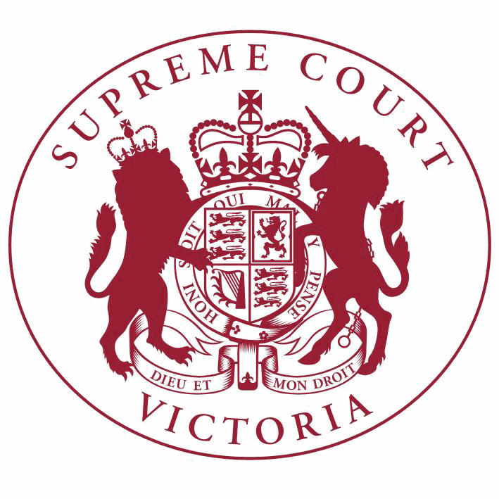

**Supreme Court List for Monday 11 June 2018**

|  |  |
| --- | --- |
| COURT OF APPEAL  courtrooms are located at: | TRIAL DIVISION  courtrooms are located at: |
| 459 Lonsdale St. Melbourne | 210 William St. Old High Court 436 Lonsdale St. WCJC Melbourne Ground Floor Melbourne 223 William St.  450 Little Bourke St. Melbourne  Melbourne |

**Practice Court (Common Law)**

10:30 Practice Court Business

**URGENT APPLICATIONS** Contact the Associate to the Practice Court Judge **(AFTER HOURS ONLY)** on

0412 251 757 or 0419 303 981

During business hours, contact the Practice Court Coordinator on 9603 9288.

**Commercial Court Duty Judge**

Commercial Court Urgent Applications

**URGENT APPLICATIONS** During business hours, contact the Commercial Court Registry on 9603 4105.

Contact the Associate to the Commercial Court Duty Judge **(AFTER HOURS ONLY)** on

0439 153 522.

**End of Listing**

[www.supremecourt.vic.gov.au](http://www.supremecourt.vic.gov.au/)

Printed: 8/06/2018 04:30:34

Page 1 of 1