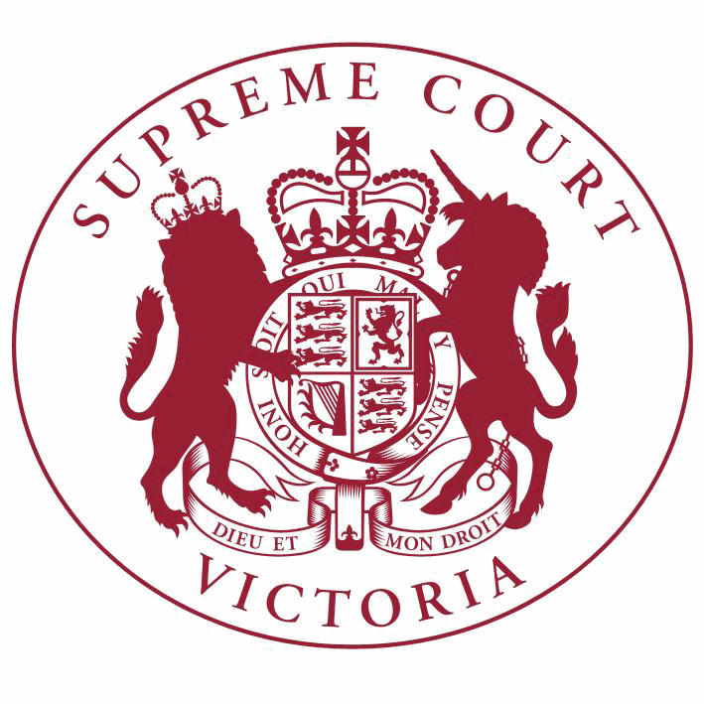

**Supreme Court List for Thursday 7 June 2018**

|  |  |
| --- | --- |
| COURT OF APPEAL  courtrooms are located at: | TRIAL DIVISION  courtrooms are located at: |
| 459 Lonsdale St. Melbourne | 210 William St. Old High Court 436 Lonsdale St. WCJC Melbourne Ground Floor Melbourne 223 William St.  450 Little Bourke St. Melbourne  Melbourne |

**Court of Appeal**

**Criminal Division**

**Justice Whelan, Justice Priest, Justice Kyrou**

Green Court, Ground Floor

459 Lonsdale Street, Melb.

4:15 S APCR 2017 0237

Iman Kargar

v. R

For Judgment - Leave to Appeal

4:15 S APCR 2017 0237

Iman Kargar

v. R

Judgment

**Acting Chief Justice, Justice Priest, Justice Kyrou**

Green Court, Ground Floor

459 Lonsdale Street, Melb.

4:00 S APCR 2017 0127

Dimi Sovolos

v. R

Judgment

4:00 S APCR 2017 0127

Dimi Sovolos

v. R

For Judgment - Leave to Appeal

4:00 S APCR 2018 0041

Aric Jarratt (a pseudonym)

v. R

Judgment

4:00 S APCR 2018 0042

Lyndon Damion (a pseudonym)

v. R

Judgment

4:00 S APCR 2018 0043

Alfonso Dennis (a pseudonym)

v. R

Judgment

4:00 S APCR 2018 0044

Toby Abu (a pseudonym)

v. R

Judgment

**Criminal Division**- Continued

4:00 S APCR 2018 0045

**Court of Appeal** - Continued

Judgment

Colby Ivor (a pseudonym)

v. R

4:00 S APCR 2018 0046

Kevin Valerio (a pseudonym)

**Acting Chief Justice**

Green Court, Ground Floor

459 Lonsdale Street, Melb.

v. R

Judgment

9:30 S APCR 2017 0188

Brendan Ian Davies

**Civil Division**

**The President, Justice Whelan, Justice Kyrou**

Red Court, First Floor

459 Lonsdale Street, Melb.

v. R

For Mention

9:15 S APCI 2018 0015

Molonglo Group (Australia) Pty

Ltd (ACN 109 342 547)

v. Peter Joseph Cahill & Ors.

For Judgment - Leave to Appeal

9:15 S APCI 2018 0015

Molonglo Group (Australia) Pty

Ltd (ACN 109 342 547)

v. Peter Joseph Cahill & Ors.

Judgment

9:15 S APCI 2018 0016

Molonglo Group (Australia) Pty

Ltd (ACN 109 342 547)

v. Peter Cahill & Ors.

For Judgment - Leave to Appeal

9:15 S APCI 2018 0016

Molonglo Group (Australia) Pty

Ltd (ACN 109 342 547)

**Justice Kyrou, Justice McLeish, Justice Niall**

Red Court, First Floor

459 Lonsdale Street, Melb.

v. Peter Cahill & Ors.

Judgment

10:30 S APCI 2017 0099

Sim Development Pty Ltd (ACN

165339524) & Ors.

v. Greenvale Property Group Pty Ltd

(ACN 159975498)

Part Heard

10:30 S APCI 2017 0099

Sim Development Pty Ltd (ACN

165339524) & Ors.

v. Greenvale Property Group Pty Ltd

(ACN 159975498)

For Hearing of Appeal

**Trial Division**

**Criminal Division**

**Justice Kaye**

Court 3, Ground Floor

210 William Street, Melb.

10:30 S CR 2017 0004

R

v. Christine Ann LYONS

Part Heard

10:30 S CR 2017 0005

R

**Justice Hollingworth**

Sitting at County Court G-1

250 William Street, Melb.

v. Ronald LYONS

Part Heard

10:30 S CR 2017 0204

R

v. Alexander Dow FREEBURN

Part Heard

**Justice Bell**

Court 4, Ground Floor

210 William Street, Melb.

9:30 S CR 2015 0170

R

**Justice T Forrest**

Court 5, Ground Floor

210 William Street, Melb.

v. Rocco NATALE

Part Heard

2:15

**Justice Beale**

S CR 2018 0152

In the matter of an application by J O

Application for Bail

Court 11, Ground Floor

210 William Street, Melb.

10:30 S CR 2016 0147

R

**Justice Jane Dixon**

Court 1, Ground Floor

210 William Street, Melb.

v. H D

Special Hearing

10:30 S CR 2017 0100

R

**Justice Champion**

Court 2, Ground Floor

210 William Street, Melb.

v. Adam BROOKMAN

Preliminary Argument

10:30 S CR 2017 0084

R

**Judicial Registrar Pedley**

Court 2, Ground Floor

210 William Street, Melb.

v. Danny Noel VOLPE

Part Heard

9:30 S CR 2018 0154

R

**Common Law Division**

**Justice Niall**

Court 7, Ground Floor

210 William Street, Melb.

**Trial Division** - Continued

v. Atila BARTA

Post Committal

Directions

Judicial Review and Appeals List

9:30 S CI 2018 00401

Mark James

**Justice John Dixon**

Court 15, Ground Floor

210 William Street, Melb.

v. K G Mason (in his capacity as State

Coroner)

For Mention

Major Torts list

10:30 S CI 2015 03382

Roo-Roofing Pty Ltd (ACN 092

931 676) & Ors.

**Justice Ginnane**

Court 6, First Floor

210 William Street, Melb.

v. The Commonwealth of Australia

Part Heard

Judicial Review and Appeals List

10:30 S CI 2017 03553

Hugo Alistair Rich

v. Brett Ryan (acting in his capacity as the General Manager of H.M. Prison Barwon and for Corrections Victoria)

Trial

10:30 S CI 2017 04399

Hugo Alistair Rich

**Justice McDonald**

Court 14, First Floor

210 William Street, Melb.

v. Brett Ryan (acting in his capacity as the General Manager of H. M. Prison Barwon and for Corrections Victoria)

For Mention

10:00 S CI 2015 03354

Paul Bannon

v. Nauru Phosphate Royalties Trust

Trial

**Justice Keogh**

Court 8, Ground Floor

210 William Street, Melb.

Major Torts list

10:30 S CI 2016 00811

Robert Marinelli

v. State of Victoria

Trial

**Common Law Division**- Continued

**Trial Division** - Continued

**Judicial Registrar Gourlay**

Mediation Room 3 Level 6 (436 Lonsdale St)

436 Lonsdale Street, Melb.

10:00 S CI 2018 01682

John Richard Horne Benzie

**Judicial Registrar Englefield**

Mediation Room 3 Level 6 (436 Lonsdale St)

436 Lonsdale Street, Melb.

v. Amaca Pty Limited (ACN 000 035

512) (formerly James Hardie & Coy

Pty Ltd) & Ors.

For Mediation

10:00 S CI 2018 00143

Angelika Grete Spratling & Ors.

**Judicial Registrar Clayton**

In Chambers

v. Khala Dee Mamot (who are sued as the executors of the will and estate of Edith Grete Frieda Noggerath, deceased) & Ors.

For Mediation

9:30 S CI 2017 00964

Craig Parker

v. K. & R.J. Matthews Quarries Pty.

Limited

By Telephone

Conference

9:30 S CI 2017 01172

Allister Prowse

v. Dyer Engineering Proprietary Limited

By Telephone

Conference

10:00 S CI 2017 05224

Troy Strange

v. Saman Mallika Weeraratne & Ors.

Post Mediation

Directions Hearing

10:15 S CI 2016 04420

Jesse Staker

**Practice Court (Common Law)**

**Justice Richards**

Court 10, Ground Floor

210 William Street, Melb.

v. Ralph John Kemp & Ors.

By Telephone

Conference

9:30 S CI 2016 00471

Butler Market Gardens Pty Ltd

(ACN 007 019 865)

v. G.G. & P.M. Burrell Pty Ltd (ACN

006 006 613)

Application

**URGENT APPLICATIONS** Contact the Associate to the Practice Court Judge **(AFTER HOURS ONLY)** on

0412 251 757 or 0419 303 981

During business hours, contact the Practice Court Coordinator on 9603 9288.

**Commercial Court**

**Justice Croft**

Court 13, First Floor

210 William Street, Melb.

**Trial Division** - Continued

10:00 [VCAT] BP246/2017

Angela Fourniotis

v. Andrew Gerry Vallianatos

Trial

**Justice Sifris**

Court 1, Ground Floor

Old High Court

450 Little Bourke Street, Melb.

Corporations List

10:00 S ECI 2016 01115

Qiang Li

**Justice Almond**

Court 9, First Floor

210 William Street, Melb.

v. Officar Pty Ltd (ACN 142 983 042) & Ors.

Appeal

10:00 S CI 2013 06267

Nick Fotopoulos

**Justice Kennedy**

Court 7B, Ground Floor

210 William Street, Melb.

v. Commonwealth Bank of Australia & Ors.

Trial

Technology, Engineering & Construction List

10:00 S ECI 2018 00027

Form 700 (NSW) Pty Ltd (ACN

600 966 201)

v. Probuild Constructions (Aust) Pty Ltd

(ACN 095 250 945)

Directions Hearing

**Justice Lyons**

Court 12, Ground Floor

210 William Street, Melb.

10:00 S CI 2016 04216

Souhail Mondous & Ors.

v. Sebastian Canzoneri & Ors.

Part Heard

**Justice Robson**

Court 2, Ground Floor

Old High Court

450 Little Bourke Street, Melb.

10:00 S ECI 2018 00076

Australian Funding Partners

Limited (ACN 167 628 597)

**Associate Justice Gardiner**

Court 5, Ground Floor

436 Lonsdale Street, Melb.

v. Wendy Diane Botsman

For Judgment

**Commercial Court**- Continued

Company Winding Up Applications

**Trial Division** - Continued

10:30

1 S CI 2017 03981

In the Matter of Colourful Kew Pty Ltd (ACN 613 896 245)

Corporations List

10:30

2 S CI 2017 03981

In the Matter of Colourful Kew Pty Ltd (ACN 613 896 245)

Application

**Judicial Registrar Hetyey**

Mediation Room 3 Level 6 (436 Lonsdale St)

436 Lonsdale Street, Melb.

Corporations List

10:00 S ECI 2018 00053

Taegetos 1 Pty Ltd (ACN 165 232

780)

**Judicial Registrar Matthews**

Court 3, Ground Floor

436 Lonsdale Street, Melb.

v. Zenon Eleftheriou & Ors.

For Mediation

2:15 S CI 2017 00561

Ching Kok Lov & Ors.

Corporations List

v. Mengkong Sok & Ors.

Directions Hearing

2:15 S ECI 2016 01302

Ching Kok Lov & Ors.

v. Mengkong Sok & Ors.

Initial Conference

**Commercial Court Duty Judge**

Commercial Court Urgent Applications

**URGENT APPLICATIONS** During business hours, contact the Commercial Court Registry on 9603 4105.

Contact the Associate to the Commercial Court Duty Judge **(AFTER HOURS ONLY)** on

0439 153 522.

**Associate Judges Associate Justice Mukhtar** Court 2, Ground Floor

436 Lonsdale Street, Melb.

10:30

1 S CI 2018 01613

Guangdong Yongtong Crane Control Machinery Industry Pty Ltd

v. Foshan City Shundequ Yongluan Metal

Materials Pty Ltd & Ors.

Directions Hearing

**Associate Judges**- Continued **Associate Justice Derham** Court 4, Ground Floor

436 Lonsdale Street, Melb.

10:30

1 S CI 2018 01463

Jean-Marc Dambra & Ors.

v. Green Village Property Development

Pty Ltd (ACN 163 873 416) & Ors.

Trial

**Associate Justice Ierodiaconou**

Court 4, Ground Floor

436 Lonsdale Street, Melb.

9:30

1 S CI 2017 01564

Alan Adams

v. Jane Wadesley & Ors.

For Judgment

**Pre-Trial Conferences Deputy Prothonotary Munro** Conference Room, Fourth Floor

436 Lonsdale Street, Melb.

2:00 S CI 2018 00550

Ian Gordon White

**End of Listing**

v. State of Victoria & Ors.

Pre-Trial Conference